Module 1 – Health and Wellness
In this module, you will explore nutrition as one part of a person's total wellness. While nutrition is a very important part of a person's overall health and wellness, it is not the only part. Wellness, as you will soon see, involves a number of different parts that are called dimensions, which together cover all aspects of a person's life. A person who is "well" balances these dimensions of wellness successfully.

Module Objectives:
On successfully completing this module, you will be able to:
- define wellness.
- identify the factors that influence one's total wellness.
- investigate the guidelines used to promote health and wellness.
- develop a personal, healthy lifestyle plan.

Wellness
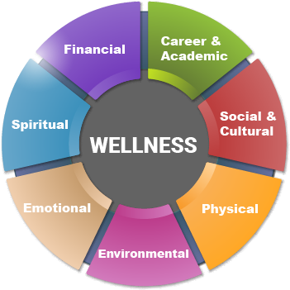
You have probably heard people talk about "wellness." It is an important goal for most people, but what does it mean?

Oxford Dictionaries defines wellness as "the state of being in good health, especially as an actively pursued goal." In this course, we will look at wellness as balancing and succeeding in seven different individual dimensions of total wellness. By doing this, you maximize your chances of living a satisfying, fulfilling life. Every person will navigate the seven individual dimensions differently, but everyone with high levels of personal wellness has good, solid approaches to each of these seven dimensions of wellness.
- Physical
Physical wellness is keeping your body healthy and able to perform daily activities. It includes:
  - healthy eating.
  - physical activity and exercise.
  - proper sleep habits.
  - regular medical care.
  - avoidance of harmful activities—alcohol, tobacco, caffeine, and so on.
- Emotional
Emotional wellness is having positive mental health, including understanding and accepting yourself for whom you are. People with good emotional wellness manage stresses well and prioritize taking care of themselves.
The Province of New Brunswick has an infographic describing emotional or mental health. (link found on Module 1 main page, tab 03)
- Environmental
Environmental wellness is living in and contributing towards a positive, healthy and safe environment. Not only does it include recognizing your impact on the natural environment, such as air and water quality, but it also includes the social environment, such as how you treat and relate to others. Of course, this is a two-way street; your environment also impacts your wellness.
- Financial
Financial wellness is being able to support yourself financially now and in the future. It includes being able to budget, plan and make sound financial decisions based on your needs and income.
- Spiritual
Spiritual wellness is aligning your values and beliefs with actions to provide a sense of purpose in your life. It addresses people's need to feel part of something bigger than themselves in the manner that speaks most directly to them. For some, this component of wellness manifests itself in formal, organized religion; for others, it is nurtured by something more personal.
- Career & Academic
Career and academic wellness is expanding your knowledge and skills and challenging your mind. It addresses our intellectual needs and our need for continual, life-long learning to best fulfill ourselves.
- Social & Cultural
The social and cultural component of wellness includes:
  - having positive relationships with friends and family.
  - dealing with difficulties with friends and family positively.
  - accepting and understanding your own culture and those of others, such as by developing an appreciation for a culture's traditions, food, art, literature, music, and other features.
Note: Different sources will combine or name these dimensions slightly differently, and so you might see sources that identify 5–9 different dimensions of wellness. In all cases, however, the dimensions are meant to include all of the factors that influence a person's health and well-being.
Visit "The 7 Dimensions of Wellness" from Simon Fraser University for more information and examples from each dimension (link found on Module 1 main page, tab 04). Check out the Student Wellness Guide there for tips on improving your health in each dimension (link found on Module 1 main page, tab 05).
You can also choose to visit the Wellness NB website for resources on wellness from the Government of New Brunswick (link found on Module 1 main page, tab 06).
In your learning guide, summarize now what you have learned about the dimensions of wellness.

Risk Factors
According to the World Health Organization, a risk factor is “any attribute, characteristic or exposure of an individual that increases the likelihood of developing a disease or injury.” Therefore, the more risk factors you have for a condition, the more likely it is that you will develop that condition at some point in your life.
Risk factors are divided into two categories: non-modifiable and modifiable. Non-modifiable risk factors are risk factors you cannot change, such as your age, heredity and sex. Modifiable risk factors are things that you can have an impact on, such as your lifestyle, environment, and health maintenance.
Non-Modifiable
Age
Your age can impact your risk of certain diseases. For instance, children younger than 2 years old and adults older than 65 years old are at greater risk of developing complications from the flu.
Heredity
Heredity risk factors are passed down to a child from a parent by way of genes. Many diseases, such as heart disease and some cancers, have a genetic component and tend to run in families. As well, your ethnic background can influence your risk of certain conditions. For example, high blood pressure is more common in adults of African heritage than in Caucasian or Hispanic adults.
Even though you can’t change these risk factors, knowing that you have them can help you to seek treatment for a condition earlier and can motivate you to make better lifestyle choices to minimize your risk.
Consider the following questions in assessing your own heredity risk factors:
- Do you have one or more close relatives with the same medical condition, such as type 2 diabetes?
- Have you had a relative diagnosed with a condition, such as heart disease, at an early age?

Sex
Your sex can also impact your risk of certain diseases. For instance, while both men and women are at risk for heart disease, women typically develop it 7–10 years later than do men.
Note: "Sex" here refers to the biological, but do not assume that sex is automatically binary: male or female. In gender theory, "sex" is the biological; "gender" is the social. "Sex" is being born male, female, or intersex based on the anatomy of an individual's reproductive system; "gender" is not only what we as societies make of that but also how we self-identify based on an internal awareness of gender.
Modifiable
Lifestyle
Lifestyle risk factors include such behaviours as the following:
- dangerous, injury-inducing activities.
- the use of drugs, alcohol and tobacco.
- sexual behaviours that could result in infections or unwanted pregnancies.
- poor diet.
- low levels of physical inactivity.
Consider the following questions to consider your own lifestyle risk factors:
- How often do you eat fresh foods (non-processed) per week?
- How often do you eat processed foods per week?
- How many soft drinks do you drink on average per week?
- How often do you choose bars, cakes, cookies, or chips for snacks per week?
- On average how much time do you spend being physically active per week?
- On average, how much time do your spend "screen watching" (TV, video games, or computers) per week?
- On average, how much sleep do you get on school nights?
- Do you smoke? Drink alcohol? Use drugs?

Environment
Environment risk factors can exist both inside and outside the home. They include air quality, noise, light, and so on.
Consider the following questions in assessing your own environmental risk factors:
- How often are you exposed to second hand smoke?
- How often are you exposed to UV rays?
Health Maintenance
Health maintenance risk factors include failing to receive regular immunizations and avoiding regular medical and dental check-ups.
Consider the following questions to consider your own health maintenance risk factors:
- How often do you visit the doctor?
- How often do you visit the dentist?
- Are your immunizations up to date?

In your learning guide, summarize now what you have learned about risk factors.

Listed on the next page are some of the harmful effects of alcohol, drugs, smoking, and obesity. Don't worry if some of the words in the effects of obesity are new to you: we will be discussing them again during Module 3: Health Trends & Issues. For more information now, watch "What Is Obesity?" by Mia Nacamulli (link found on Module 1 main page, tab 07).
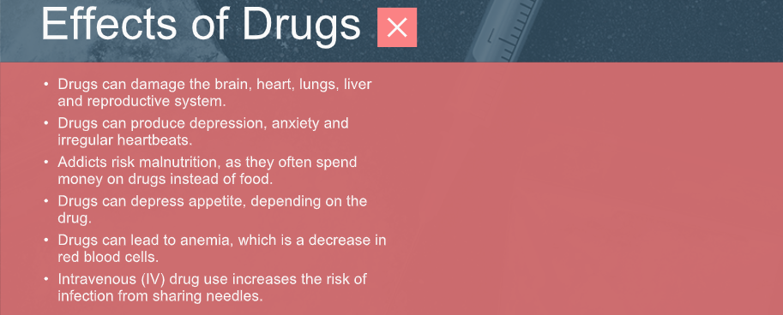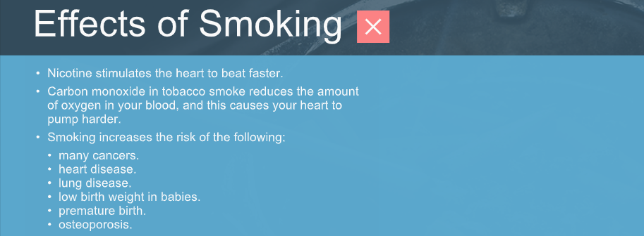

Wellness Guides
Now that you have demonstrated an understanding of wellness and risk factors generally, we will start to narrow our focus. No single course could ever hope to cover all seven dimensions of wellness in great detail during a single high school semester, so of course, as we move along, the focus of Nutrition for Healthy Living 120 will eventually be a portion of the physical dimension: nutrition.
Still, before we hone in on nutrition alone, we will first discuss it alongside physical activity and mental wellness. All dimensions of wellness impact the others, but these are two of the most directly linked to nutrition.

Guidelines to Promote the Physical Component of Wellness
To help Canadians improve their physical wellness, Health Canada promotes three wellness guides:
- Canada's Food Guide (link found on Module 1 main page, tab 08).
- Canadian 24-Hour Movement Guidelines (link found on Module 1 main page, tab 09).
- Tips To Get Active: Physical Activity Tips for Youth (12–17 Years) (link found on Module 1 main page, tab 10).

Canada's Food Guide
Health Canada produced Canada's Food Guide to provide an easy-to-follow guide that helps most users to meet their daily nutrient requirements. The guide delineates the types of foods—and the relative proportions of these foods–individuals should consume each day.
A photograph of a plate organizes foods into three groups:
- vegetables and fruit.
  - Vegetables and fruit should comprise approximately ½ of your plate each meal. Choose different textures, colours and shapes.
  - Eating a variety of vegetables and fruits may lower your risk of heart disease. Vegetables and fruits provide important nutrients such as fibre, carbohydrates, vitamin A, vitamin C, some B vitamins, potassium, and magnesium.
  - Vegetables and fruit include fresh, frozen, canned and dried forms. Choose ones without added sugars, seasonings, sodium, breading or rich sauces. Draining and rinsing canned vegetables can lower the sodium content. Because dried fruit can stick to your teeth and cause cavities, eat it with meals.
  - Use healthier cooking methods when preparing vegetables, such as baking, roasting, steaming or stir-frying instead of deep frying. To enhance the flavour, add olive oil, lemon juice, flavoured vinegar or herbs or spices.
  - Vegetables and fruit do not include fruit candies, vegetable chips, fruit jams or spreads, ketchup, vegetable or fruit punch, or vegetable or fruit "drinks." Even 100% fruit juices are high in sugars. Replace juice with water, and choose whole or cut vegetables and fruits instead of juice.
- whole grain foods.
  - The grains food group is an important source of carbohydrates (especially fibre), several B-vitamins, iron, zinc, and magnesium.
  - Choose a variety of whole grains foods such as quinoa, whole grain pasta, whole grain bread, whole oats or oatmeal, and whole grain brown or wild rice. Whole grain foods include all parts of the grain. Processing removes some parts of the grain in refined grains; this processing is why whole grain foods have more fibre than refined grains. Eating higher fibre foods can help to lower your risk of stroke, colon cancer, heart disease and Type II diabetes.
  - In Canada, non-whole grain bread and pasta are "enriched" with several B-vitamins and iron. This process restores those nutrient lost when the bran and germ layers of the grains were removed during processing.
  - Ensure that your choices are actually whole grain by reading the label. Whole wheat and multi-grain might not be whole grain. On the ingredient list, look for the words “whole grain” followed by the name of the grain as one of the first ingredients, such as whole grain oats or whole grain wheat.
  - Choose grain foods lower in added sodium, sugars or saturated fat. Many breads, muffins, crackers and pasta dishes have a lot of added sodium, sugar or saturated fat.
  - Prepare whole grain foods by minimizing the amount of salt added during preparation; limiting the amount of sauce or spreads you add; and by adding vegetables, vegetable oils, spices and herbs to enhance flavour.
- protein foods.
  - Protein foods include beans, lentils, nuts, seeds, lean meats, poultry, fish, shellfish, eggs and lower fat milk and dairy products.
  - In addition to protein, these foods can be important sources of iron, zinc, magnesium, B-vitamins, calcium and fat.
  - Plant-based protein foods can provide more fibre and less saturated fat than animal-based protein foods. This can be beneficial for your heart health, so choose plant-based protein foods more often.
  - Choose protein foods without added sugars, fat or sodium. This includes avoiding breaded, battered and deep-fried options. It also means choosing unsweetened milk and soy products. Select lean meat; skinless poultry; and low fat milk, yogurt and cheese to minimize your intake of saturated fat.
  - When you cook, try baking, grilling, roasting or poaching to avoid adding saturated fat. Enhance the flavour by using herbs, lemon juice or salsa or by using small amount of oils with unsaturated fats, such as olive or canola.
The glass of water in the photograph highlights the recommendation that...
...water should be your drink of choice.
- Water should be your drink of choice. Many other drink options contain a lot of calories, sodium, sugars and saturated fat.
- Water is important for your health and helps replace water lost by sweating, breathing and getting rid of waste.
- You can add fruits and herbs to water for flavour or try carbonated water if you prefer a fizzy drink.
- Other healthy drink options can include lower fat white milk, unsweetened soy and almond beverages and unsweetened coffee and teas. Be mindful of the caffeine that can be found in coffee, tea, colas and energy drinks. It is a stimulant that affects children more than adults.
- Avoid drinks that are high in sodium, sugars or saturated fat. These can include sugary drinks, alcoholic drinks, vegetable juices, and hot chocolate or specialty teas and coffees made with higher fat dairy.

In addition, Canada’s Food Guide includes the following advisories to promote healthy eating:
- Be mindful of your eating habits.
Be aware of how, why, what, when, where and how much you eat. This awareness can help you to make healthier choices more often.
- Cook more often.
Cooking more often can help you develop healthy eating habits by relying less on highly processed foods, controlling the amount of sauces and seasonings and allowing you to choose healthy foods. In addition, you can save money by not eating out!
- Enjoy your food.
Part of healthy eating is enjoying your food. It helps you focus on tasting the flavours and being open to trying new foods. It can also include enjoying shopping for food, growing your own food or getting to know the people who produce your food.

- Eat your meals with others.
Enjoying healthy foods with others can help you connect and add enjoyment to your life. It can also help you share food traditions across generations and cultures and expose you to healthy foods you might not normally try.
- Use food labels.
Using food labels helps you to make informed choices. In particular, they can help you to know what ingredients a food product contains and to choose products with a little or a lot of nutrients that are of interest to you. We will look at food labels in more detail later in the course.
- Limit foods high in sodium, sugars or saturated fat.
You should limit your consumption of highly processed foods. Highly processed or prepared foods and drinks can add excess sodium, sugars and saturated fat to your diet.
These include:
  - sugary drinks.
  - chocolate and candies.
  - ice cream and frozen desserts.
  - fast foods like French fries and hamburgers.
  - frozen dinners such as pasta dishes and pizzas.
  - bakery products such as muffins, buns and cakes.
  - processed meats such as sausages and deli meats.
Some processed foods are healthy, and some do not have added sodium, sugars or saturated fat. Pasteurizing foods, for example, can make them safer to consume. Drying, canning and freezing foods help to preserver them and retain nutrients.
- Be aware of food marketing.
Food marketing is advertising that promotes the sale of certain food products, many of which are high in sodium, sugars or saturated fat. In addition to traditional commercials, food marketing can come in harder to recognize forms such as sponsored social media posts; celebrity endorsements and reviews; and product placement in TV, movies and social media posts.
By being aware of food marketing, you can recognize when foods are being marketed to you and decide whether a food item is healthy by using food labels and other sources rather than relying solely on the marketing messages. We will look at food advertising in more detail later in the course.
In your learning guide, summarize what you have learned about Canada's Food Guide.
In your learning guide, record the recommendations for balancing activity levels over 24 hours in the 24-Hour Guidelines for Movement
In your learning guide, record the amount and types of physical activities recommended in Tips To Get Active: Physical Activity Tips for Youth (12–17 Years).

Canada's Strategy for Mental Health
The MHCC released Changing Directions, Changing Lives: The Mental Health Strategy for Canada in 2012. From 2013–2015, the Youth Council of the MHCC then produced a youth perspective on this strategy (link found on Module 1 main page) to make it more accessible for a younger audience.
Both of these documents are different from the guidelines we've studied so far in this module: they include advice and recommendations for shaping the future of mental health care in Canada in the form of strategic directions for the health system, government and other involved stakeholders:
Strategic Direction 1 | Encourage lifelong mental health in all social environments where  people live or spend time and prevent mental health issues and  suicide wherever possible.
Strategic Direction 2 | Focus the mental health system on recovery and well-being for  people of all ages and protect the rights of people with mental  health issues.
Strategic Direction 3 | Give people access to the right services, treatments, and supports  when and where they find them.
Strategic Direction 4 | Ensure everyone has access to appropriate mental health services  based on their needs, especially in diverse and remote communities.
Strategic Direction 5 | Work with First Nations, Inuit, and Métis to meet their distinct  mental health needs while respecting their unique experiences,  rights, and cultures.
Strategic Direction 6 | Inspire leadership, share knowledge, and encourage collaboration  at all levels.

In the process of explaining what these strategic directions would look like for Canada, the Youth Council of the MHCC defines 20 key words. Go through the document now, and record the definitions of the key words in your learning guide.
Now complete and submit –
  - Discussion Question 1 – Food Guide Comparison

