Save this learning guide and complete each module as it is assigned. When submitting your learning guide on teams, please submit only one document with the work you have completed up to that point. Every two weeks as you are ready to submit your work, remove the previous document and replace it with your updated work.
- You are responsible for writing the answers out yourself.
- Copying and pasting answers from the reading material into this document will result in a mark of incomplete for the assignment.
- Failure to complete all components of the learning guide will result in a final grade of incomplete on your report card.

Categorizing Nutrients

Explain why macronutrients are called "macronutrients." What are the three types of macronutrients?

Describe the features of the nutrients by filing in the table below. This chart summarizes some of the information later in the Learning Guide:
 |  |  |  |  | Macronutrients
Brief description including amount required and relationship to energy
Types |  | Carbs |  |  |  |  |  |  |  | Fats |  |  |  |  |  | Protein
Elements in structure
What are the building blocks?
Amount of energy provided (kcal/g)
Recommended % of total energy intake
List Types
Description, including examples and/or sources

How many kilocalories does each of the three types of macronutrients provide?
Carbohydrates provide (text) calories per gram.
Proteins provide (text) calories per gram.
Fats provide (text) calories per gram.
Extra: Alcohol provides (text) calories per gram. Alcohol provides energy: why do you think that it is not considered a macronutrient?

Digestive System

Type of Digestion | Description
1
2

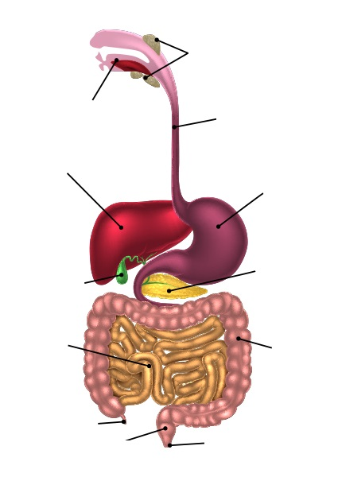
(label)
(label)
(label)
(label)
(label)
(label)
(label)
(label)
(label)
(label)
(label)
(label)

Carbohydrates

Carbohydrates are made up of molecules of which three elements:

1.
2.
3.

What percentage of your total energy intake should come from carbohydrates according to Health Canada?

Structure of Carbohydrates

Identify and describe the four structures of carbohydrates.

Carbohydrate Structure | Number of Linked  Sugar Molecules | Examples
1
2
3
4

What are the three broad types of dietary carbohydrates?

1.
2.
3.

What is the difference between simple and complex carbohydrates?

Fibre

Identify and describe the two types of fibre.

Types | Description
1
2

What are some of the health risks associated with a low fibre diet?

Digestion of Carbohydrates

Identify the three important disaccharides that are broken down in the small intestine, the digestive enzyme that breaks down each of them and the monosaccharides that are produced as a result.

Disaccharide | Digestive Enzyme | Resulting Monosaccharides
1
2
3

How many kcal does soluble fibre provide per gram?

Regulating Blood Glucose

What organ monitors the level of glucose in your blood and secretes hormones to regulate your blood sugar level?

Explain the roles of insulin and glucagon in the regulation of blood sugar.

Hormone | Effect on Blood Glucose | Description of its Effect on Blood Glucose Levels*
Insulin
Glucagon
*Make sure you include which other organs are involved and what happens to glycogen in the process.

Glycemic Index

In general, what are the benefits of choosing complex over simple carbohydrates?

Define and describe "glycemic index." Include in your answer a description of all three GI ranges including examples of each.

Problems with Carbohydrate Digestion

Identify the five problems identified in the course content, and explain how they relate to carbohydrate digestion.

Problem or Condition | Relation to Carbohydrate Digestion
1
2
3
4
5
Calculating Your Individual Needs from Carbohydrates

What are the three steps for calculating your maximum recommended carbohydrate intake in both kilocalories and grams?

1.
2.
3.

Fats

Fats are made up of molecules of which three elements:

1.
2.
3.

What are three important roles of fats in the body?

1.
2.
3.

Digestion, Absorption and Transportation of Fats

What is the goal of fat digestion?

What is lingual lipase, and what role does it serve in the digestion of fats?

What is bile, and what role does it serve in the digestion of fats?

How are fats absorbed into the body? Include in your response a description of the roles played by the villi and the lymphatic system.

Storage of Body Fat

What is the name of the tissue that stores fat?

What materials can the body use to make fat?

In theory, how much energy does one pound of fat provide?

Describe what the body does when it needs energy. Be sure to include the order or hierarchy of energy sources it uses.

Calculating Your Individual Needs from Fats

Describe the steps in calculating your maximum recommended fat intake.

1.
2.
3.

What is the maximum percentage of your daily recommended energy intake that should come from saturated fats?

What is the maximum percentage of your daily recommended energy intake that should come from trans fats?

Health Risks of Too Much Fat

Describe the types of fat, which have been identified for you. Include in your description whether the type of fat is solid or liquid at room temperature (when applicable):

Types of Fat | Description | Physical State at Room Temperature | Effect on Cholesterol | Good Dietary Sources
Saturated
Unsaturated
Trans
Omega-3 Fatty Acids

What is cholesterol and what is its role in your body?

Where does cholesterol come from?

What is the difference between LDL and HDL? Include in your explanation their roles in heart disease.

What are some ways you can reduce your risk of heart disease?

Protein

Proteins are made up of molecules of which four elements:

1.
2.
3.
4.

Which one of these elements is not found in molecules of carbohydrates or fats?

What are the building blocks of protein? Include in your answer the term "peptide bond."

Which percentage of your total energy intake should come from proteins according to Health Canada?

How many kcal does a gram of protein provide?

Digestion, Absorption, Transportation and Metabolism of Proteins

What are proteases, and what is their role in the digestion of proteins?

Where in the body does protein get mostly digested? Describe what happens to protein in this organ.

What is the end product of digesting proteins, and how is it absorbed and transferred throughout the body?

What is protein used for in the body?

Protein Requirements of the Body

What percentage of your total energy intake should come from protein if you are between 4 and 18 years of age?

What are the two types of protein sources, and what do they mean for vegetarians?

What is meant by an "essential" amino acid? How many essential amino acids are there?

Calculating Your Individual Needs from Proteins

What are the three steps in calculating your maximum recommended protein intake as both kilocalories and grams?

1.
2.
3.

How do you calculate your daily RDA of protein based on your weight?

Effects of Excessive or Insufficient Protein

What happens to excess protein in the body?

What are the effects of insufficient protein?

What is PEM? Who is at risk of it, and what happens to someone who suffers from it?

Micronutrients

What are three ways in which micronutrients differ from macronutrients?

1.
2.
3.

Why is it impossible to name the elements common to all molecules of vitamins as we did for the three macronutrients?

Vitamins

What roles do vitamins perform in the body?

What are antioxidants? Include in your answer both examples and benefits of antioxidants.

What do "fortified" and "enriched" mean on food labels?

Types of Vitamins

Identify and describe the two basic types of vitamins.

Type | Description | Good Dietary Sources

Which vitamins are water soluble?

Which vitamins are fat-soluble?

Complete the following chart:

Vitamin | Main Functions | Diseases and Symptoms of Deficiency | Good Dietary Sources
Vitamin B1—Thiamin
Vitamin B2—Riboflavin
Vitamin B3—Niacin
Vitamin B9—Folacin, Folate or Folic Acid
Vitamin B12—Cobalamin
Vitamin C
Vitamin A—Retinol
Vitamin D
Vitamin E
Vitamin K

For some vitamins, regularly consuming significantly more than is required is unlikely to lead to problems, but consuming more than is needed of other vitamins could to health problems. Overconsumption of which vitamins is more likely to lead to health problems? Why?

Other Properties of Vitamins

How can vitamins be destroyed?

1.
2.
3.
4.
5.

What is a precursor or provitamin? In your answer, define beta-carotene.

Minerals

What are minerals? What happens to them in the body?

Dietary Requirements for Minerals

What are the two categories of minerals? What is the difference between them?

Complete the following chart:

Major Mineral | Main Functions | Diseases and Symptoms of Deficiency | Good Dietary Sources
Calcium
Magnesium
Potassium
Phosphorus
Sodium
Trace Mineral | Main Functions | Diseases and Symptoms of Deficiency | Good Dietary Sources
Iodine
Fluorine
Iron
Zinc

What can happen if you consume too much sodium?

Vitamins and Minerals

Compare and contrast vitamins and minerals using the Venn diagram.

[Type here]
[Type here]
[Type here]
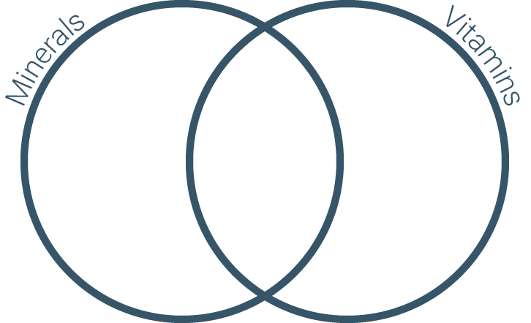

Fortification
Why are foods fortified or enriched?

What nutrients must be added to the following foods in Canada?

Food | Nutrient | Benefit
Flour
Cow's milk other than skim
Skim milk
Margarine
Table salt

Water

List the functions water serves in the body.

1.
2.
3.
4.
5.
6.
7.
8.

Daily Requirements of Water

What percentage of your total water intake comes from beverages? What percentage comes from food?

According to the Food and Nutrition Board, how many litres of water should women drink daily? Men?

Why are caffeinated drinks a poor choice as a source of water?

Effects of Excessive or Insufficient Water

What are the symptoms of dehydration?

What are the effects of excessive water?

