Module 2 – Nutrients

In this module, you will refine your knowledge of nutrition—the science of food and its effects on the body. During Module 1: Health and Wellness, you learned about the four food groups in Canada's Food Guide; now, we will look deeper into nutrition by examining the nutrients found in the foods from each of the food groups. While the recommended number of food guide servings per day remains important information, you can monitor and improve your diet more effectively by adding in Daily Recommended Intake (DRI) guidelines for both macronutrients and micronutrients. Recommended serving sizes are the broad brush strokes that start a painting; the DRIs for macro- and micronutrients are the details that complete the painting.

Module Objectives:
On successfully completing this module, you will be able to:
- define the six categories of nutrients.
- identify the roles of carbohydrates in the body.
- identify the roles of fat in the body.
- identify the roles of protein in the body.
- identify the roles of vitamins in the body.
- identify the roles of minerals and water in the body.
- calculate the recommended intake of carbohydrate, protein, and fat to meet your needs.
- analyze your intake of important nutrients.

Categorizing Nutrients
We will start our study of nutrients by defining briefly the different types of nutrients and by categorizing different nutrients. Then, as we move through Module 2: Nutrients, we will be adding to these descriptions with much more detail.

Macronutrients
Carbohydrates |  | Protein |  | Fats
Complex | Simple | Complete | Incomplete | Saturated | Unsaturated | Trans Fats
Starch | Sugars |  |  |  | Monounsaturated
Fibre |  |  |  |  | Polyunsaturated

Micronutrients
Vitamins |  | Minerals
Water Soluble | Fat Soluble | Major | Trace
B | A | Calcium | Iron
C | D | Magnesium | Zinc
 | E | Sodium | Iodine
 | K | Potassium | Fluoride
 |  | Phosphorous

Water

Macronutrients
Carbohydrates, fats, and proteins are sometimes called "macronutrients" because the body requires large amounts of them. These organic nutrients are "energy-yield" nutrients.
Carbohydrates
Carbohydrates, also called “saccharides,” are chemical compounds consisting of atoms of carbon, hydrogen and oxygen. "Saccharide" means sugar, and all carbohydrates are made up with sugar molecules. They are found mainly in foods from plant sources, such as grain products, fruits, vegetables, dry beans and peas. Their main function is to provide energy to the body. Each gram of digested carbohydrate provides four kilocalories (kcal) of food energy. Carbohydrates should comprise 45–65% of your total energy intake.

Proteins
Proteins, like fat and carbohydrates, are made up of carbon, hydrogen and oxygen, but unlike the other two macronutrients, proteins also contain nitrogen. Amino acids are called the "building blocks" of protein. Each amino acid has a central carbon atom that connects to an amino group, an acid group and a distinctive side group. Peptide bonds link together these molecules in chains to form proteins. These chains vary in length from a few amino acids to several thousand amino acids.
Protein provides 4 kcal of energy per gram. Youth from 4–18 should consume approximately 10–30% of their total energy from protein. Most North Americans consume more protein than is needed.

Fats
Fats are also referred to as "lipids." They are made up of carbon, hydrogen and oxygen. "Fatty acids" are the building blocks of fats. Fats found in foods are combinations of monounsaturated, polyunsaturated and saturated fatty acids. Fats are one of the three energy nutrients, and they provide 9 kcal of energy per gram—more than twice the amount of kcal in carbohydrates or proteins! Youth from 4–18 should have 20–30% of their total energy intake from fat, and less than 10% of total energy intake should come from saturated fat. Most North Americans consume too much fat.

Complex carbohydrates
Complex carbohydrates are oligosaccharides and polysaccharides: long chains of monosaccharides (sugar molecules) linked together. There are three complex carbohydrates important in nutrition:
- starch.
- fibre.
- glycogen.
Starch and fibre must be broken down by the body's digestive system to be used as energy. Glycogen is one way the body stores energy. The body makes glycogen and stores it in the liver for your muscles to use later.

Simple Carbohydrates
Simple carbohydrates are monosaccharides and disaccharides. Collectively, they are known simply as "sugars." Monosaccharides are single sugar molecules, and two monosaccharides join to form a disaccharide. Sugars are a natural part of many foods. There are six important dietary sugars:
Three Monosaccharides | Three Disaccharides (Pairs of Monosaccharides)
Glucose | Maltose (made up two glucose molecules)
Fructose | Sucrose (made up of one glucose and one fructose molecule)
Galactose | Lactose (made up of one glucose and one galactose molecule)
Glucose, a monosaccharide, is the most important sugar in the body. It is the end product of digesting carbohydrates and the body's main source of energy. When it circulates in the blood, it is known as blood glucose or blood sugar.

Complete Protein
Complete proteins contain all of the essential amino acids, the amino acids your body cannot synthesize (or make) on its own. Complete proteins are found in animal products and soybeans. Because you cannot make essential amino acids on your own, you must consume them in your food. Of the 22 known amino acids, 9 are essential.

Incomplete Protein
Incomplete proteins do not contain all nine essential amino acids. They are from plants, and they are sometimes known as "complementary proteins." You must eat a variety of incomplete proteins to get all of the essential amino acids; each incomplete protein "complements" the others to form a complete set—or "complement"—of the nine essential amino acids.

Saturated Fats
Saturated fats are solid at room temperature. They usually come from animal sources.

Unsaturated Fats
Unsaturated fats are usually liquid at room temperature. Most plant oils—with the exception of tropical oils such as coconut oil, palm oil, and cocoa butter—are unsaturated.

Trans Fats
Small amounts of trans fats occur naturally in some foods from animal sources, but most trans fats are created through a chemical process called hydrogenation. During hydrogenation, hydrogen is added to the chemical structure of fasts to change them from a liquid to a solid state to increase their "shelf life."

Monounsaturated Fats
Monounsaturated fats are found in the following oils:
- olive.
- canola.
- peanut.

Polyunsaturated Fats
Polyunsaturated fats are found in the following oils:
- corn.
- sunflower.
- soybean.
- flaxseed.
- pumpkin.

Micronutrients
Vitamins and minerals are sometimes called "micronutrients" because the body only requires small amounts of them daily—milligrams or micrograms. These nutrients do not provide energy. They are instead "energy-releasers" because they help your body to metabolize the three macronutrients: carbohydrate, fat, and protein.

Vitamins
Vitamins are complex organic substances vital to life. Some are fat-soluble, and some are water-soluble.

Minerals
Minerals are inorganic substances that can become part of the body when they are absorbed. They can be found in your bones, teeth and fluids. They do not yield energy, but they have many essential roles in the body. After they enter the body, they remain there until you excrete them.

Water-Soluble Vitamins
Water-soluble vitamins (vitamins B and C specifically) are found in the water in foods: when they are absorbed, they move directly to the bloodstream. They are easily excreted in body fluids, and therefore, you must replace them continually.

Fat-Soluble Vitamins
Fat-soluble vitamins (vitamins A, D, E and K specifically) are found in the fats and oils of foods: They must first enter the lymph before they are absorbed into the blood. They often attach to proteins to be transported throughout the body. They are stored in fatty tissue and the liver until needed, and therefore, you might not need to replace them as frequently as you do the water-soluble vitamins.

Major Minerals
Major minerals are so named because of the amounts present in the body and needed by the body, not because they are any more important than the trace minerals. Major minerals are required in much larger amounts—grams or hundreds of milligrams.

Trace Minerals
Trace minerals are required in smaller amounts than are the major minerals. Trace minerals are required in tens of milligrams or even micrograms (1 milligram equals 1,000 micrograms).

Water
Water is essential to life. It participates in many metabolic reactions. It provides the medium for transporting vital materials to cells and waste products away from them. In the body, water is the essential part of the fluids in which life processes occur. The body is approximately 60% water. Dehydration can easily develop with either water deprivation or excessive water loss.
In your learning guide, describe the nutrients defined above, and complete the other fields for notes based on this screen.

Digestion
As we examine each of the types of nutrients more closely over the coming submodules, we will also discuss how they are digested in the body.
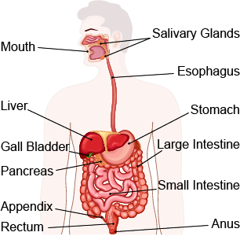

Let's review basic digestion first—before we discuss how macronutrients and micronutrients are digested in the body.
Mechanical digestion is the physical breakdown of food into smaller, more digestible chunks—chewing. The teeth and tongue do this job quite well.
Chemical digestion involves the use of digestive enzymes to separate food materials into much smaller components. Saliva contains a chemical that begins this process, and chemical digestion continues in the stomach and the small intestine.
The human digestive tract begins with the mouth and ends at the anus. The tract is a long, twisting tube that involves various digestive organs. Most of the digestive organs (stomach and intestines, for example) are tube-like and contain the food as it makes its way through the body. A few other organs (the liver, gall bladder and pancreas, for example) produce or store digestive chemicals that act on the food as it moves through the tract.
Visit the US Department of Health and Human Services (link found on Module 2 main page, tab 3) for a more detailed look at the form and function of the digestive system.
In your learning guide, record your notes on digestion and the digestive system.

Carbohydrates are chemical compounds made up of molecules of sugar, which are themselves composed of carbon, hydrogen and oxygen. Carbohydrates are found mainly in foods from plant sources, such as grain products, fruits, vegetables, dry beans and peas. Their main function is to provide energy to the body. Each gram of digested carbohydrate provides 4 kilocalories (kcal) of food energy. According to Health Canada, carbohydrates should comprise 45–65% of your total energy intake.

Structure of Carbohydrates
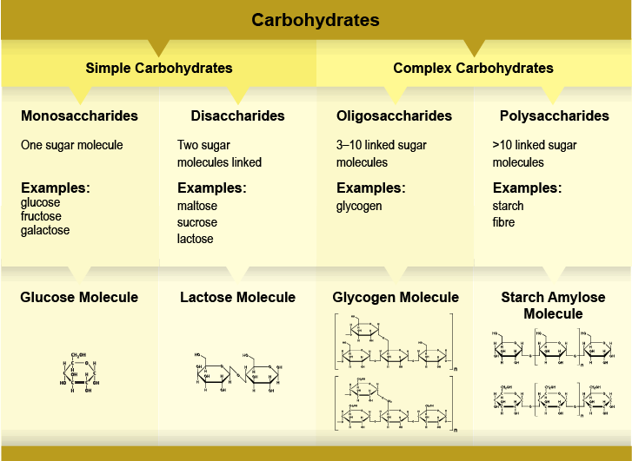

Examples of the Four Types of Carbohydrates
Glucose Molecule
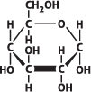
Lactose Molecule
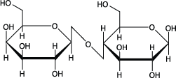
Glycogen Molecule
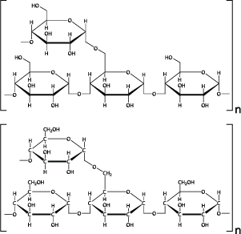

Starch Amylose Molecule
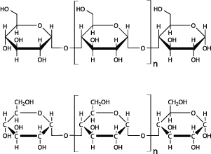

Visit this resource on carbohydrates from Anthony Carpi (link found on Module 2 main page, tab 4) for more detail on the structure of carbohydrates.
In your learning guide, record your notes now on carbohydrates and the structure of carbohydrates.

Dietary Carbohydrates
There are three broad types of dietary carbohydrates:
- sugar
- starch
- fibre
Sugar refers to the simple carbohydrates: both monosaccharides and disaccharides. Monosaccharides are single sugar molecules, and two monosaccharides join to form a disaccharide. The names of these sugars generally end in "-ose." Sugars are a natural part of many foods including fruit and milk.
Monosaccharides are absorbed directly into the bloodstream.
- glucose
Glucose is the most important sugar in the body. It is the end product of digesting carbohydrates, and it is the body's main source of energy. When it circulates in the blood, it is known as blood glucose or blood sugar.

- fructose
Fructose, also known as fruit sugar, is found in fruits, most root vegetables and honey. It is converted to glucose in the liver.
- galactose
Galactose is converted to glucose in the liver.
Disaccharides are pairs of monosaccharides. They must be broken down into monosaccharides before they can be absorbed. Click each of the three important dietary disaccharides for more information.
- maltose
Maltose (made up of 2 glucose molecules) is not found in high quantities in foods naturally, but it can be formed by the digestion of starches.
- sucrose
Sucrose (made up of glucose and fructose) is commonly known as table sugar. Virtually all plants contain some amount of sucrose, but the sugar industry typically uses sugarcane or sugar beets from which to extract sucrose.
- lactose
Lactose (made up of glucose and galactose) is the main sugar in milk and other dairy products.
Starch is how energy is stored in plants. It is found largely in the seeds and roots of plants. Dietary sources of starch include the following:
- legumes, such as dry beans, peas and lentils.
- vegetables, such as potatoes and corn.
- grain products, such as rice, pasta and breads.

Fibre is the structural part of plants. Vegetables, fruits, legumes and grains are all sources of dietary fibre. There are two types of dietary fibre. Click each type of dietary fibre for more information.
- soluble fibre
Soluble fibre is found in legumes and fruits. It dissolves in water to forms a gel-like substance in the stomach and small intestine that slows digestion and the absorption of nutrients.
Because of this, soluble fibre can help to protect against diabetes by lowering and regulating blood glucose levels. It can also protect against cardiovascular disease by attaching to cholesterol particles and taking them out of the body in the faeces, thus reducing the level of cholesterol in the blood.
Some soluble fiber is fermented in the colon to yield 2 kcal/g of energy.
- insoluble fibre
Insoluble fibre is found mostly in grains and vegetables. It does not dissolve in water, and it is not readily fermented, so it passes through your digestive tract relatively unchanged.
Insoluble fibre adds bulk and consistency to faeces and promotes regularity in bowel movements, and these effects help to alleviate constipation.
For an overview of fibre, watch "Fiber: Lowering Cholesterol" (link found on Module 2 main page, tab 5) by the Visual MD.

For more information on fibre, visit this site from the Harvard School of Public Health. (link found on Module 2 main page, tab 6)

In your learning guide, record your notes about fibre now.

Digestion and Absorption of Carbohydrates
The type of carbohydrate affects how the body digests it—or whether the body digests it at all. Of the three broad types of dietary carbohydrates that we discussed on the previous screen, sugar and starch are readily digestible, but fibre is not.
Let's take a closer look at the process of digesting carbohydrates.

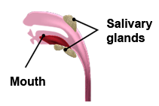 |  |  |  | The mechanical and chemical digestion of carbohydrates begins in the mouth. Food is chewed and mixed with saliva. The salivary enzyme amylase starts to break the bonds between the sugar molecules in starches to make shorter polysaccharides and disaccharides. Because food does not remain in the mouth very long, very little digestion takes place in the mouth. The lining of the mouth, though, might absorb some glucose.
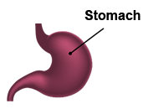 |  | In the stomach, the bolus (the ball of swallowed food) mixes with the acid in the stomach and protein-digesting enzymes. The acidity in the stomach inactivates salivary amylase, and most starch and fibre are not digested. They linger in the stomach, delaying gastric emptying (emptying of the stomach) and leaving you with the feeling you are full.
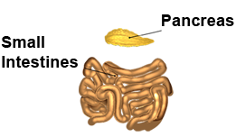 |  |  |  |  | Most carbohydrate digestion takes place in the small intestine. Pancreatic amylase, the major carbohydrate-digesting enzyme, travels through a duct from the pancreas to the small intestine. There, it breaks down the bonds between sugar molecules, converting polysaccharides into oligosaccharides and disaccharides.  Specialized enzymes then break down the disaccharides into monosaccharides. For instance, the enzyme maltase breaks maltose into two glucose molecules; sucrase breaks sucrose into one glucose and one fructose molecule; and lactase breaks lactose into one glucose and one galactose molecule. (Fructose and galactose will be converted into glucose after being processed in the liver.)  Most nutrient absorption also takes place in the small intestines. Villi along the intestinal wall absorb these monosaccharides into the bloodstream.
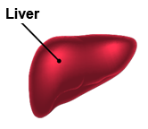 | After they are absorbed into the bloodstream, the monosaccharides travel to the liver via the portal vein. In the liver, galactose and fructose are converted to glucose.
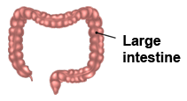 |  |  | The remaining carbohydrates—resistant starches and fibre—leave the small intestine and enter the large intestine, which is also known as the colon. These promote bowel movements! Bacteria in the digestive tract ferment both the soluble fibre and the resistant starches. The fatty acids produced by this fermentation are absorbed in the colon and yield 2 kcal of energy per gram.

For an overview of the digestion of carbohydrates watch "What Are Carbohydrates?" (link found on Module 2 main page, tab 7) by the Visual MD. This video also serves as a good overview of carbohydrates.
Watch also this explanation emphasizing the chemical processes behind the digestion of starch (link found on Module 2 main page, tab 8) from Armando Hasudungan. If you don't get bogged down in the chemical structures of starch and the enzymes as shown here, you will find these illustrations very helpful in understanding how starch is broken down and absorbed.
In your learning guide, record your notes now about the digestion and absorption of carbohydrates.

Regulating Blood Glucose
As you've learned, the main function of carbohydrates is to provide energy to the body in the form of glucose. This energy affects the health and functioning of all cells in the body, and it is crucial to the functioning of the brain and nervous system.
Your pancreas monitors the level of glucose in your blood. When it is too high, the pancreas releases insulin, and this triggers the liver and muscle cells to remove glucose from the blood and store it as glycogen: 2/3 is stored in muscles for future energy use, and 1/3 is stored in the liver. When blood glucose drops below a certain level, the pancreas secretes the hormone glucagon to trigger the liver to convert glycogen back to glucose, which is then released into the blood for energy.
In your learning guide, record your notes now about the regulation of blood sugar levels.

Glycemic Index
As you would expect, all foods that contain carbohydrates raise your blood sugar level as they are digested and absorbed. However, how much and how quickly different foods raise the level of glucose in your blood varies. The more constant your blood sugar levels, the less risk you have of developing conditions such as cardiovascular diseases and diabetes. Therefore, foods that cause a gradual, small rise in blood sugar levels are preferred over those that cause a quick and dramatic spike. In general, complex carbohydrates take longer to digest than simple carbohydrates do. They tend to satisfy hunger longer, and as they are digested, blood sugar rises gradually and slowly. However, some foods that are high in starch, a complex carbohydrate, are easily digested and provoke a quick, dramatic rise in blood sugar.
A reliable way of predicting the impact of a food on your blood sugar is using the Glycemic Index (GI), a rating that describes how quickly the carbohydrates in food are processed into glucose and transferred into the bloodstream. The higher the number, the more quickly the food is processed into glucose and raises blood sugar levels. The highest possible GI is 100—for glucose itself. Note: You might see slightly different GI values in other sources depending on the scientific studies used. As well, the GI values can vary even for a single food. For instance, a very ripe banana has a higher GI than a green banana.
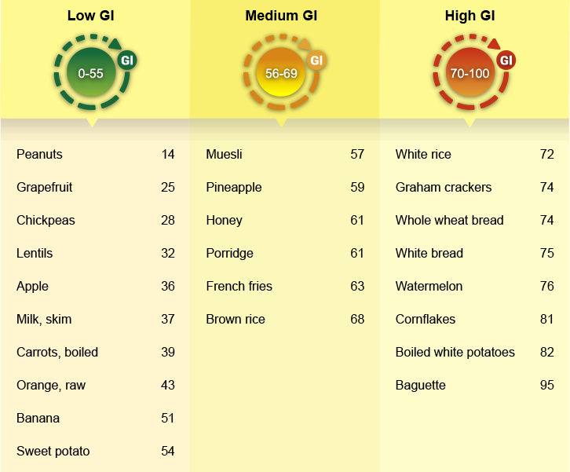

In your learning guide, record your notes about GI levels now.

Problems with Carbohydrate Digestion
When your body cannot digest carbohydrates properly or when you consume too much or too little of different types of carbohydrates, problems can arise.
- tooth decay
Tooth decay happens when teeth are exposed to too many simple carbohydrates from processed foods, such as candy, pretzels and chips. Bacteria in your mouth feed on sugars to form plaque on your teeth and gums. As these bacteria digest the sugars, they produce acids, which themselves weaken the enamel, the outermost layer of your teeth.
- lactose intolerance
Lactose intolerance occurs when the body produces too little of the enzyme lactase, and without it, the milk sugar lactose passes undigested out of the small intestine. Consuming dairy products, the main sugar in which is lactose, causes a lactose intolerant person to suffer from cramps, diarrhea, bloating, and nausea.
- irritable bowel syndrome
Irritable Bowel Syndrome (IBS) is a condition that causes those affected to suffer diarrhea, constipation, cramping, or bloating. People with IBS typically have healthy—or at least undamaged—digestive tracts, but still they suffer these symptoms.
While no single food provokes IBS across all sufferers, some carbohydrates can provoke the symptoms of IBS: fructose from honey or some fruits, foods high in insoluble fibre, and resistant starch. The resistant starches are also known as Fermentable Oligosaccharides, Disaccharides, Monosaccharides and Polysaccharides (FODMAPs). After FODMAPs pass undigested into the colon (large intestine) from the small intestine, bacteria ferment them, and that process produces gas and bloating to some extent in everyone, but for those with IBS, the gas and bloating is excessive or painful.
Some sufferers benefit from increasing their dietary intake of soluble fibre.

- inflammatory bowel disease
Inflammatory Bowel Disease (IBD) comprises a group of inflammatory diseases of the intestines, including Crohn's disease and colitis. Typical symptoms of IBD include abdominal pain, diarrhea, and cramping. Low fibre and low FODMAP diets have helped to alleviate symptoms for some sufferers of IBD.
- constipation
Constipation occurs when there is insufficient insoluble fibre in the colon (large intestine), and the movement of dietary waste towards the anus stalls or slows.

For more on the problems that can arise digesting carbohydrates, watch "How Do Carbohydrates Impact Your Health?" (link found on Module 2 main page, tab 9) by Richard J. Wood. This video also serves as a good review of carbohydrates generally!
In your learning guide, identify and describe the five problems with carbohydrate digestion discussed above.

Calculating Your Individual Needs from Carbohydrates
To reiterate, according to Health Canada, for all age and sex groups, 45–65% of total energy needs—which are expressed as kcals—should come from carbohydrates. Each gram of digested carbohydrate provides 4 kcal of food energy.
To calculate your maximum recommended carbohydrate intake, you must do the following:
- Determine the maximum recommended intake of carbohydrates as a percentage of your total recommended energy intake for your age and sex. In this case, the recommended range is from 45–65%, so the maximum recommended intake is 65% of your total recommended energy intake.
- Find 65% of your recommended daily energy intake in kcal per day by converting the percentage to its decimal form and then multiplying that by your total energy intake. For example, if your daily recommended energy intake is 2100 kcal, then you multiply that number by 0.65 to get your carbohydrate maximum:
2100 kcal x 0.65 = 1365 kcal
In this example, you should consume no more than 1365 kcal daily from carbohydrates.
- Convert your daily maximum recommended carbohydrate intake from kcal to grams. Because there are 4 kcal in each gram of digested carbohydrates, divide by 4 to complete the conversion:
1365 kcal ÷ 4 kcal/g = 341.25 g
In this example, you should consume no more than 341.25 g of carbohydrates each day.

Let’s try - Jose has a daily recommended energy intake of 3200 kcal. What is his maximum recommended daily intake of carbohydrates expressed as both kcal and grams?
1. 3200 kcal x 0.65 = 2080 kcal
2. 2080 kcal ÷ 4 kcal/g = 520 g
Jose should consume no more than 2080 kcal or 520 g of carbohydrates per day.
In your learning guide, record the two ways of calculating your daily maximum carbohydrate intake.
A Triglyceride Molecule
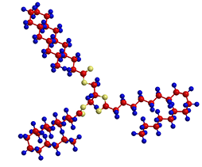
Like carbohydrates, fats are composed of carbon, hydrogen and oxygen. They are triglycerides composed of three fatty acid molecules and one glycerol molecule. These molecules of fatty acids are the building blocks of fat. The exact structure of the fatty acid chains determines whether a fat is liquid at room temperature (an oil) or solid at room temperature. In general, fats are insoluble in water (they don’t dissolve in water).
Fat has many important roles in our bodies:
- It is essential for normal brain development.
- It insulates and protects our organs.
- It is necessary for the absorption and storage of vitamins A, D, E and K.

For more on the structures of fat molecules and the problems that can arise from saturated and trans fats, watch "The Deal with Fat" (link found on Module 2 main page, tab 10) from SciShow.

In your learning guide, record your notes about fats now.

Digestion, Absorption and Transportation of Fats
Linoleic Acid: A Fatty Acid
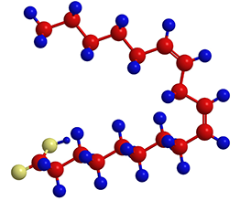
The goal of fat digestion is to dismantle the triglycerides into small molecules that the body can absorb and use: monoglycerides (which are one fatty acid molecule attached to one glycerol molecule) and free fatty acids.
As with carbohydrates, digestion begins in the mouth when body heat begins to melt hard fat and food is chewed into small pieces. The salivary gland at the base of the tongue releases an enzyme called lingual lipase, but in adults, very little digestion takes place here. This enzyme is more effective in the digestion of milk by infants. In the stomach, muscle contractions mix food and expose fat to the gastric lipase enzyme. This enzyme breaks down short-chain fatty acids; however, again, very little digestion takes place. Unlike carbohydrates, fats are slow to digest and can take up to seven hours to break down. When food is ready to leave the stomach and move into the small intestine, it is in a liquid form called "chyme."
As with carbohydrates, fats are mostly digested in the small intestine. Here digestion is aided by the liver, gall bladder and pancreas. Bile, which is manufactured from cholesterol in the liver and stored in the gallbladder, flows in from the gallbladder. It acts to emulsify fat with watery fluids to help in its absorption. Emulsification means that the fat is broken down into very small droplets so that it will stay mixed with the watery fluids even though it isn’t soluble in water. The smaller droplets also increase the surface area of the fat. Pancreatic lipase, another enzyme, flows in from the pancreas. It, along with enzymes in the small intestine, removes both outer fatty acids from the triglyceride, leaving a monoglyceride. Sometimes enzymes remove all three fatty acids, leaving a molecule of glycerol.

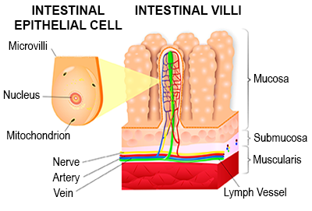
Most of the products of fat digestion can diffuse from the lumen of the small intestine directly into the intestinal cells. As they do with carbohydrates, again the villi—tiny, finger-like projections—help with this absorption by increasing the surface area of the walls of the small intestine. Some of the products of fat digestion can cross into the intestinal cells only with help from transporter proteins in the cell membrane.
Once they are inside the intestinal cells, these products of fat digestion are re-assembled into new triglycerides. These re-assembled triglycerides and other large lipids (cholesterol and phospholipids) are transported by lipoproteins through the lymphatic system until they reach a duct near the heart where they can enter the bloodstream. The blood in the circulatory system then carries them to the rest of the body.
However, not all dietary fat gets absorbed in the small intestine. Do you remember from the Submodule 1: Carbohydrates that dietary fiber traps some fat in the small intestine? This process explains how dietary fibre can help to reduce blood cholesterol. This material—the fibre with absorbed fat—passes into the large intestine and is be removed as waste to complete the process of digestion.
For more on the structures of fat molecules and the problems that can arise from saturated and trans fats, watch "What Is Fat?" (link found on Module 2 main page, tab 11) by George Zaidan.
Note: This video includes the American maximum for a zero trans fat label: 0.5 g of trans fat per serving. In Canada, our labelling laws have a maximum of 0.2 g of trans fat per serving on a product labelled as having zero trans fats. Moreover, not all types of pancake mix contain trans fat.
In your learning guide, record your notes about the digestion, absorption and transportation of fats now.

Storage of Body Fat
Fat is stored in the body’s adipose tissue as an energy reserve. Fat can be made and stored in the body from the fat present in the foods we eat, or it can be made in the body from carbohydrates and protein and then stored as fat. The body requires more energy to reconstruct fat from carbohydrate and protein than it does from fatty acids.
One pound (454 g) of body fat provides 3,500 kcal or energy. If you consume more energy than your body uses, the excess is converted and stored as fat. If you eat less than your body requires, your body will call on its reserve supplies to give it energy. Therefore, in theory, you would need to consume 3,500 kcal less than you need to lose one pound of body fat, and conversely, consuming 3,500 kcal more than you need would result in your gaining one pound of fat. In reality, the body’s metabolism reacts to changes in caloric (energy) intake, so this is not always the case.
When your body needs more energy, it first looks for glycogen, which you will remember is made during the digestion of carbohydrates and is stored in the liver and muscles. The body breaks down the glycogen to glucose to get the energy that it needs. After that, your body will turn to breaking down stored fat into glycerol and fatty acids. The fatty acids can either be broken down directly for energy, or they can be converted to glucose. As a last resort, your body will break down protein as an energy source. Using protein for energy is not as efficient; it also means that those amino acids are no longer available to build the specialized proteins the body needs elsewhere.
For more details on this process, read How Fat Cells Work (link found on Module 2 main page, tab 12) from Craig Fruedenrich.
In your learning guide, record your notes about the digestion, absorption and transportation of fats now.

Calculating Your Individual Needs from Fats
Many Canadians are eating more fat than they require. The recommendation is that people 4-years-old and older should consume 35% or less of their total daily caloric requirement from fat. For example, if your body requires 2,000 kcal of energy each day for the activities you perform, then at most 700 kilocalories should come from fat in your diet. Because each gram of fat provides 9 kcal of energy, you should consume no more than 78 grams of fat each day.
Health Canada’s DRI Tables indicate that saturated fat and trans fat intakes should be as low as possible while consuming a nutritionally adequate diet. The World Health Organization (WHO) is more specific; it recommends that less than 10% of your total energy intake come from saturated fats and less than 1% of total energy intake come from trans fats. Both sources recommend replacing saturated and trans fats with unsaturated fats whenever possible.
To calculate your maximum recommended fat intake, you must do the following:
- Determine the maximum recommended intake of fat as a percentage of your total recommended energy intake for your age and sex. For people 4-years-old and older, the maximum recommended intake of total fat is 35% of your total recommended energy intake.
- Find 35% of your recommended daily energy intake by converting the percentage to its decimal form and then multiplying your recommended daily energy intake as kcal by it. For example, if your recommended daily energy intake is 2000 kcal, then you multiply that number by 0.35 to get your daily recommended maximum fat intake:
2000 kcal x 0.35 = 700 kcal
In this example, you should consume no more than 700 kcal daily from fats.
- If you need to know your daily recommended maximum fat intake in grams, convert kcal of fat to g of fat. Because there are 9 kcal in each gram of fats, divide by 9 to complete the conversion:
700 kcal ÷ 9 kcal/g = 77.8 g
In this example, you should consume no more than 77.8 g of fats each day.
- Find your recommended daily maximum intake of saturated fats by multiplying your recommended daily energy intake by 10% (0.10):
2000 kcal x 0.10 = 200 kcal
In this example, you should consume no more than 200 kcal of saturated fats per day.
- Find your recommended daily maximum intake of trans fats by multiplying your recommended daily energy intake by 1% (0.01):
2000 kcal x 0.01 = 20 kcal
In this example, you should consume no more than 20 kcal of trans fats per day.

Let’s try - Wanda has a recommended daily energy intake of 3500 kcal. What is her daily maximum fat intake expressed as both kcal and grams? What is the recommended maximum amount of saturated fat and trans fat for her in grams?
Total Fat:
1. 3500 kcal x 0.35 = 1225 kcal
2. 1225 kcal ÷ 9 kcal/g = 136.1 g
Saturated Fat:
3. 3500 kcal x 0.10 = 350 kcal
4. 350 kcal ÷ 9 kcal/g = 38.9 g
Trans Fat:
5. 3500 kcal x 0.01 = 35 kcal
6. 35 kcal ÷ 9 kcal/g = 3.9 g
In your learning guide, record how you calculate your daily recommended fat intake.

Health Risks of Too Much Fat
Too much fat in your diet is linked to cardiovascular disease, certain types of cancer, type II diabetes, and obesity and related illnesses. However, as you've already seen during this module, the type of fat is very important. Use the links below and other sites to find out the differences among saturated, unsaturated and trans fats. Be sure to know the effects on the body and sources of each.
Visit the following sites for more information on the health effects of fat in your body. Be sure to pay particular attention to the sources and effects of each type of fat—saturated, unsaturated, trans, cholesterol and Omega-3:
- Heart and Stroke Foundation of NB's "Dietary Fats, Oils and Cholesterol" (link found on Module 2 main page, tab 13)
- The Mayo Clinic's "Heart-Healthy Diet: 8 Steps To Prevent Heart Disease" (link found on Module 2 main page, tab 14)
- Eat Right Ontario's "Facts on Cholesterol" (link found on Module 2 main page, tab 15)
- Harvard School of Public Health's "Types of Fats" (link found on Module 2 main page, tab 16)
In your learning guide, record information about each type of fat. You will need to use these sites to find this information.

Leucine: an Amino Acid
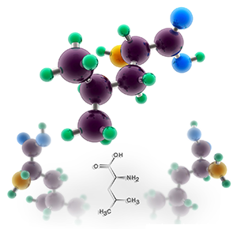
Proteins have the same three elements as fats and carbohydrates: carbon, hydrogen and oxygen. Molecules of proteins, however, include a fourth element: nitrogen.
Amino acids are the "building blocks" of protein. Each amino acid has a central carbon atom that connects to a hydrogen atom, an amino group, a carboxyl group and a distinctive side group called the R-group or side chain. These molecules are linked together in chains by peptide bonds to form proteins. These chains vary in length from a few amino acids to several thousand.
Protein provides 4 kcal of energy per gram. You should consume approximately 10–15% of your total energy from protein. Most North Americans consume more protein than required.
In your learning guide, start to record your notes about protein now.

Digestion, Absorption, Transportation and Metabolism of Proteins
In the mouth, proteins are moistened with saliva and crushed with the chewing motion of the teeth before being swallowed. Only the mechanical digestion of protein occurs there.
Proteins are very complex molecules arranged in chains of amino acids. The amino acids are held together by peptide bonds. During digestion, these peptide bonds are broken by protein-digesting enzymes called proteases. Unlike carbohydrates and fats, for which most digestion occurs in the small intestine, most chemical digestion of proteins happens in the stomach. The stomach secretes an enzyme called pepsinogen. The hydrochloric acid secreted in the stomach helps convert pepsinogen into the protease pepsin, which in turn attacks the peptide bonds that hold the amino acids together in the protein chain. This process causes the proteins to be broken down into shorter chains called polypeptides.
Digestion continues in the upper part of the small intestine—the duodenum. The pancreas secretes the enzyme trypsin, which breaks the polypeptides into simple amino acids through a process called hydrolysis. After breaking down, the amino acids are small enough to pass through the finger-like projections in the small intestine called the villi. The amino acids are absorbed into the bloodstream and carried to the cells by both the red blood cells and by the liquid part of the blood—the plasma. The amino acids are distributed to all body tissues, where the various body cells take what they need to repair and reform the protein structures they require. All dietary proteins are absorbed before they ever reach the large intestine.
Each protein has a specific function in the body, and each protein is constantly being synthesized and broken down as needed. Proteins are used within the body in many ways: proteins serve as a component of many parts of the body, including body tissues, blood plasma, hemoglobin, enzymes, hormones, and antibodies.
For an overview of the digestion of proteins watch "What Are Proteins?" (link found on Module 2 main page, tab 17) by the Visual MD. This video also serves as a good overview of proteins.
Watch also this explanation (link found on Module 2 main page, tab 18) from Armando Hasudungan. If you don't get bogged down in the chemical structures of the amino acids and enzymes as shown here, you will find these illustrations very helpful in understanding how proteins are broken down and absorbed.
In your learning guide, record your notes about the digestion, absorption and metabolism of protein now.

Protein Requirements of the Body
Experts are still not entirely sure how much protein we need, and estimates are often revised. Both national and international health organizations, which advise on nutrient requirements, suggest standards that are calculated to meet or exceed the requirements of practically everyone, taking into account individual variation, such as age, sex, energy requirement and so on. Health Canada guidelines suggest that for anyone over the age of three, eating 10% of our daily energy as protein will provide an adequate amount. Most North Americans consume much more than this minimum amount. As with protein and carbohydrates, there is a recommended range. For people between 4 and 18 years of age, 10–30% of your total energy intake should come from protein.
To reiterate, there are two types of protein sources:
- Complete proteins are found in animal products and soybeans. They contain all essential amino acids, which are the amino acids your body cannot synthesize or make on its own. In other words, because you cannot make essential amino acids on your own, you must consume them in your food. Of the 20 amino acids used to build proteins in the body, 9 are essential.
- Incomplete proteins are sometimes known as "complementary proteins." You must eat a variety of plants to get all of the essential amino acids; each single plant "complements" the others to form a complete set—or "complement"—of the nine essential amino acids.
Therefore, if someone follows a vegetarian diet, eating a variety of plant-based incomplete proteins is critical to meeting daily minimum protein requirements.
For an overview of amino acids, watch "Amino Acids" (link found on Module 2 main page, tab 19) by the Visual MD.
In your learning guide, record your notes about protein requirements now.

Calculating Your Individual Needs from Proteins
If you require 2100 kcal/day, how many grams of protein should you consume daily?
To calculate your maximum recommended protein intake, you must complete the following:
- First, determine your recommended maximum protein intake as a percentage of your recommended daily energy intake. For youth aged 4–18-years-old, that is 30%.
- Then, calculate 30% of 2100 kcal while remembering that 30% = 0.30:
0.30 x 2100 kcal = 630 kcal
You should consume no more than 630 kcal from protein.
- Finally, convert kcal of protein to grams of protein. Because there are 4 kcal in every gram of protein, to convert from kcal to g, divide by 4:
630 kcal ÷ 4 kcal/g = 157.5 g
That means you should consume no more than 157.5g of protein each day.
Let’s try - Emily is 16, and she has a daily recommended kcal per day of 1900. What is her daily maximum protein intake expressed as both kcal and grams
1. 1900 kcal x 0.30 = 570 kcal
2. 570 kcal ÷ 4 kcal/g = 142.5 g
Calculating the Minimum Recommended Protein Intake (RDA)
Another way to calculate the protein requirement is based on weight. If your weight is in the normal range on the Body Mass Index (BMI) chart, the RDA for a healthy teenager who is 14–18 years old is 0.85 grams per kilogram of protein per day. Refer to the Health Canada DRI Tables for amounts for other ages.
To calculate this, multiply your weight in kilograms by 0.85 g. (Remember, to convert from pounds to kilograms, divide by 2.2.) For example, if you are 15-year-old boy who weighs 72 kg, your RDA for protein is the following:
72 kg x 0.85 g/kg = 61.2 g of protein.
This means that a 15-year-old boy who weighs 72 kg should eat approximately 61.2 grams of protein daily.
In your learning guide, record how you calculate your maximum and minimum protein intakes now.

Effects of Excessive or Insufficient Protein
Most Canadians do not have a concern about the amount or quality of protein in our diet. We generally have more than we require. Overabundance of protein has no benefit—it often has negative health effects. If you consume more protein than your body requires, the surplus amino acids may be converted to glucose for energy use or converted to fatty acids and stored as adipose tissue. To reiterate, excess energy intake increases your risk of not only obesity and subsequently heart disease but also some types of cancer. In addition, excessive protein causes your kidneys to work harder to expel the nitrogen-based by-products of metabolizing protein. For people with even mild kidney disease, consuming a high protein diet increases the rate of kidney disease and decline.
On the other hand, insufficient protein can lead to malnutrition and devastating diseases. People deprived of protein, energy, or both develop Protein-Energy Malnutrition (PEM). This condition affects many malnourished children in developing countries or countries affected by war, disease, drought, or other types of devastation. In our society, PEM is often evident in people living in poverty, elderly people who live alone, drug addicts, alcoholics, AIDS patients, cancer patients, or people suffering from eating disorders. When there isn’t enough energy found in the diet, the body will first deplete its carbohydrate and fat reserves to produce energy. However, the body will eventually turn to protein as an energy source, which means that muscle tissue is degraded to become energy, and other protein sources in the body, such as enzymes, can also be converted to energy.
For a closer look at PEM, watch "What Happens If We Don’t Get Enough Proteins?" (link found on Module 2 main page, tab 20) by Nutrition Steps.
In your learning guide, record your notes about too much or too little protein now.

Micronutrients
Vitamins and minerals are complex substances vital to life. Vitamins and minerals are micronutrients. Micronutrients differ from the macronutrients—carbohydrates, proteins and fat—in three ways.

Structure
Vitamins and minerals exist as discrete molecules; they are not linked together to form long chains. Individual minerals are often part of a chemical compound known as a salt. Each vitamin has its own molecular structure, such as the following:
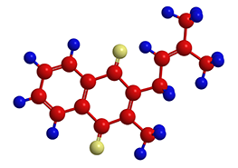  Vitamin K | 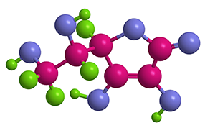  Vitamin C

Function
Micronutrients do not provide energy; they are instead energy releasers, as they help your body to metabolize the three macronutrients: carbohydrate, fat and protein.

Required amounts
Vitamins and minerals are needed in very small amounts, and these amounts are measured in only milligrams or micrograms.
In your learning guide, record the differences between macronutrients and micronutrients.
Vitamins are organic substances; the vitamin molecules are made from living organisms. They are absorbed by the body, but they do not become part of the body’s structure. Vitamins combine with coenzymes to help chemical reactions take place in the body. Metabolism is an example of that type of chemical reaction in the body. Vitamins team up with other nutrients to perform various functions, and the body cannot function properly without them. Fruits and vegetables are excellent sources of vitamins, especially if eaten raw. As we will investigate in more detail later in this module, vitamins and minerals are also added to several foods; these are labelled "fortified" or "enriched."
You might hear some vitamins referred to as "antioxidants." Antioxidants are molecules that inhibit the oxidation of other molecules. Humans need oxygen to live, but oxygen causes undesirable oxidation—a process similar to the one that turns sliced apples and potatoes dark when they are cut and exposed to air. Oxidation sometimes produces dangerously reactive substances called "free radicals." Although free radicals are normally formed in the body and the body has its defenses against such substances, these free radicals can still damage key components, such as DNA, proteins and fats (lipids). Antioxidants are capable of stabilizing free radicals before they can cause harm in much the same way that coating sliced apples with lemon juice (rich in ascorbic acid, also known as vitamin C) will prevent browning. For this reason, antioxidants may help protect your body from heart disease, some cancers and some eye problems.
Examples of antioxidants include vitamins A (and its pre-cursor, beta-carotene), C and E as well as the mineral selenium. Other substances, such as the flavonoids and carotenoids found in some plants, can also be antioxidants.
Visit "Vitamins" (link found on Module 2 main page, tab 21) from MedLine Plus for a great overview on vitamins.
In your learning guide, start your notes on the types of vitamins now.

Types of Vitamins
There are two basic types of vitamins: water-soluble and fat-soluble.
Water-soluble vitamins, which include the B-vitamins and vitamin C, mix only with water and cannot be stored by the body. Excess amounts are excreted in the urine. Replenishing them each day is important.
Fat-soluble vitamins dissolve in lipids instead of water, so fat is required for their absorption. These vitamins are usually carried in the blood in lipoproteins, and your body stores any extra that you consume in fatty tissues and the liver. This group of vitamins includes vitamins A, D, E and K.
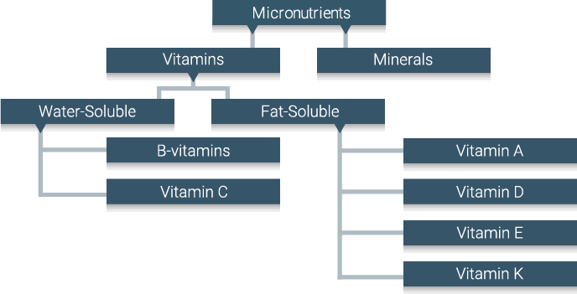
Visit "Listing of Vitamins" (link found on Module 2 main page, tab 22) from Harvard Health Publishing for the functions and foods sources of vitamins. Note that the daily recommended intakes may be slightly different from the ones from Health Canada.
For a good overview of vitamins and the digestion and distribution of both types of vitamins in the body, watch "How Do Vitamins Work?" (link found on Module 2 main page, tab 23) by Ginnie Trinh Nguyen.
In your learning guide, record your notes on the types of vitamins now.

Other Properties of Vitamins
Vitamins can be destroyed by heat, oxygen, acid, alkali or processing. You must take care to preserve them when preparing foods. For example, when you boil vegetables, a lot of the vitamins they contain normally dissolve into the water.
Have you ever heard that eating carrots is good for your eyes? Beta-carotene helps protect eyes from degenerating with age.

While the body cannot make most vitamins, it can sometimes assemble them from raw materials. A precursor is a compound that can be changed into a vitamin in the body. Vitamin precursors are also called provitamins; these precursors are not vitamins themselves. Vitamin A, for example, is made from the precursor beta-carotene in the intestines and liver. The precursor of vitamin D is made from cholesterol in the liver. Some amino acids are also precursors for some vitamins.
Beta-carotene is found in fruits and vegetables such as the following:
- onion.
- pumpkin.
- tomato.
- peppers.
- broccoli.
- sweet potato.
- carrots.
In your learning guide, record your notes about the other properties of vitamins now.
Minerals, like vitamins, are micronutrients that the body needs. Unlike vitamins, minerals are inorganic. They are not produced by living organisms; they come from the earth, soil and water. You might recognize many of them from chemistry class, as all of the dietary minerals are individual elements on the periodic table. (Not all elements on the periodic table are dietary minerals, though!).
Minerals are not destroyed by heat, oxygen, acid, alkali or processing. After they are absorbed, they do become part of the human body: they contribute to the structures of cells, fluid, muscles and bones. Once minerals enter the body, the mineral elements themselves remain as they are they are until excreted. Some are easily absorbed and transported in fluids while others are similar to fat-soluble vitamins and need to be absorbed and transported by carriers.
Vitamins and minerals often work as a team to keep the body healthy and all systems functioning properly. They boost your immune system, support growth and development and help cells and organs do their jobs. Both vitamins and minerals are vital to your health. Like vitamins, minerals do not provide the body with energy.
Visit "Minerals" (link found on Module 2 main page, tab 24) from MedlinePlus for a comprehensive look at minerals.
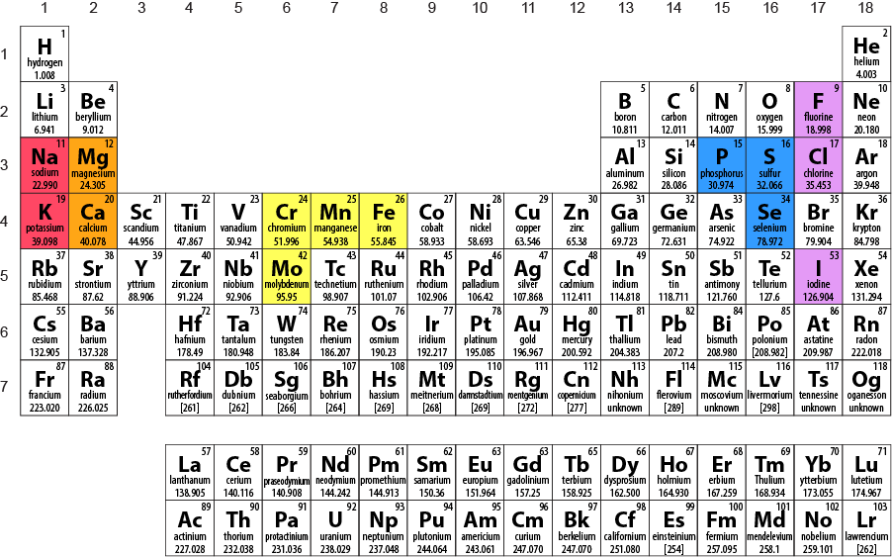

Dietary Requirements for Minerals
Minerals are grouped into two categories: major minerals and trace minerals. Both groups are equally important—the names of the categories represent the amounts that the body needs, not the relative importance. Major minerals are needed in larger amounts (0.1 g or more daily) than the trace minerals (0.01 g or less per day). There are seven major minerals: sodium, potassium, calcium, phosphorus, chloride, sulfur and magnesium. There are nine trace minerals: iron, iodine, zinc, copper, manganese, fluorine, chromium, selenium and molybdenum. Compared to the macronutrients, both major and trace minerals are needed in much smaller amounts.
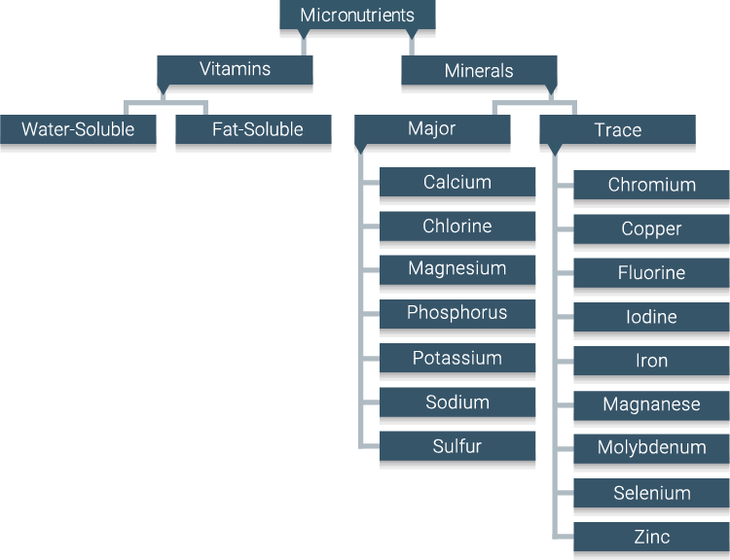
Visit "Listing of Vitamins and Minerals" from Harvard Health Publishing (link found on Module 2 main page, tab 22), "Minerals: Their Functions and Sources—Topic Overview" (link found on Module 2 main page, tab 25), from WebMD and other sites to record the primary functions, deficiency symptoms and food sources of the minerals listed in your Learning Guide. Note: The recommended intake values listed on these sites differ slightly from the Health Canada recommendations we use.
Watch "High Blood Pressure May Be a Choice" (link found on Module 2 main page, tab 26), from Michael Greger on the effects of dietary sodium on blood pressure.
For an optional overview of table salt (and pepper), watch "Why Salt and Pepper?" (link found on Module 2 main page, tab 27) by Alexandra Panzer.
In your learning guide, record your notes on minerals now.

Although both vitamins and minerals are micronutrients, they differ in several ways:
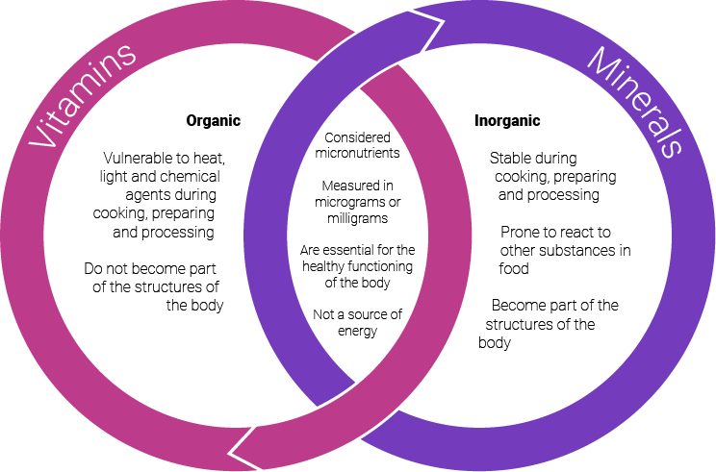

Visit "Vitamins and Minerals" (link found on Module 2 main page, tab 28) from Teens Health and "What is the Difference between Vitamins and Minerals?" (link found on Module 2 main page, tab 29) from Columbia University for more details.
In your learning guide, record the differences and similarities between vitamins and minerals now.

Fortification
In Canada, the Canadian Food Inspection Agency (CFIA) mandates that several types of foods be fortified and permits several other types of foods to be fortified. "Fortification" means adding or re-adding micronutrients to the food during processing to boost its nutritional value and to offset the loss of micronutrients during its production.
Visit "Food Fortification with Vitamins and Minerals" (link found on Module 2 main page, tab 30) from the Canadian Public Health Association and "Foods to Which Vitamins, Mineral Nutrients and Amino Acids May or Must be Added" (link found on Module 2 main page, tab 31) from the CFIA for more details.

Supplements
In addition to consuming fortified process foods, people sometimes choose to take a vitamin or mineral supplement to ensure that they are ingesting enough of a particular or a variety of micronutrients. Whether this practice is safe or necessary can be contentious. As a general guideline, however, the majority of people who follow the guidelines found in Canada's Food Guide are safe to rely on their diets alone as the source of micronutrients. Specific subgroups of the larger population—such as pregnant women or seniors—might benefit from specific supplements tailored to their needs.
You can visit the longer Health Canada site (link found on Module 2 main page, tab 32) for cautions and warnings on supplementing with micronutrients.
Lastly, the Office of Dietary Supplements, a division of the American National Institutes of Health has a list of fact sheets about dietary supplements. (link found on Module 2 main page, tab 33)
In your learning guide, log your notes about fortification and supplements now, including the nutrients that are required to be added to flour, milk, margarine and table salt.
Water is a vital nutrient. You need a regular supply of water to help your body perform its many life-supporting activities. You can live several days without food, but only a few days without water!
Water is essential for sustaining life. It makes up about 60% of an adult's body weight. Water cleans toxins from the body, cushions joints, aids in digestion, and helps transport nutrients throughout the body.
Water serves many functions in the body:
- transporting water-soluble vitamins.
- helping to eliminate waste.
- aiding in regulating body temperature.
- maintaining the structure of large molecules, such as protein and glycogen.
- maintaining blood volume.
- acting as a solvent for nutrients.
- cushioning the spinal cord and joints of the skeleton.
- cushioning the fetus during pregnancy.
In your learning guide, log your notes about water now.

Daily Requirements of Water

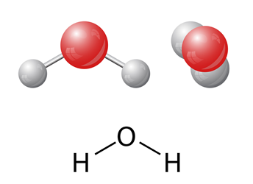
Research indicates that about 80% of your total intake of water comes from beverages, and the other 20% comes from food. Your body requires water even before it senses the feeling of thirst. You lose 2–3 liters of water each day simply through perspiration, breathing and excretion.
Your exact water requirements fluctuate with your diet, your activity level, the temperature and the humidity level. The recommendations for adults are based on energy expenditure. If you use 2000 kcal/day, you need 2–3 liters of fluid/day. In the latest report by the Food and Nutrition Board, recommendations were set at 2.7 litres of total water from all food and beverages for women and 3.7 litres for men.
To get your daily requirement of water, choose fluids such as plain water, fruit juices, milk and soups. Most fresh fruits and vegetables contain a high percentage of water—as much as 90%. Beverages with caffeine, such as soft drinks, energy drinks, coffee and tea, are not the best sources or water, as the caffeine in these drinks stimulate your body to excrete fluids.
In your learning guide, record your notes on the daily water requirements now.

Effects of Excessive or Insufficient Water

Dehydration
The first sign that you need more fluid is the feeling of thirst. If fluids are not replenished as they are lost, the body can become dehydrated. Dehydration can happen quickly, and it is can be caused by any of the following:
- intense exercise.
- extreme heat.
- severe vomiting.
- severe diarrhea.
The signs and symptoms of dehydration include the following, listed in order of increasing severity:
- thirst.
- dark-coloured urine.
- fatigue.
- dizziness.
- confusion.
- death (possible).

Toxicity
Water intoxication is very rare, but it can occur if the body takes in excess fluid after being dehydrated, in a person with a kidney disorder that reduces urine production, or when eliminating urine is prevented. The symptoms include confusion, convulsions and heart failure, and it can even cause death in extreme cases. The Food and Nutrition Board has not issued a UL for water.
For an overview of water, watch "What Would Happen If You Didn't Drink Water?" (link found on Module 2 main page, tab 34) by Mia Nacamulli.
In your learning guide, record your notes on the effects of excessive or insufficient water now.

Now complete and submit –
  - Discussion Question 1 – Food Guide Comparison
  - Assignment 1 – Perfect Week

