Module 3 – Health Trends and Issues
In this module, you will explore the potential health consequences of poor nutritional choices by examining a number of the most common chronic conditions in Canada: cancer, cardiovascular diseases, diabetes, osteoporosis, obesity, eating disorders, and dental and oral diseases. We will also explore some fad diets and trends in contemporary nutrition. We are constantly bombarded with advice on fitness, weight loss and healthy eating, but not all advice is worth taking—not all fad diets are safe or advisable. You will evaluate them in light of Canada's Food Guide and Health Canada's DRI Tables.

Module Objectives:
On successfully completing this module, you will be able to:
- define chronic condition.
- identify the following chronic conditions and how to reduce your risk of developing them:
  - cancers.
  - hypertension.
  - atherosclerosis.
  - strokes.
  - Type II diabetes.
  - osteoporosis.
  - obesity.
  - eating disorders.
  - dental and oral diseases.
- investigate current trends and issues related to nutritional health.
- understand how energy balance applies to weight management.

Chronic Conditions
What are chronic conditions? What causes them? What statistics are available? How can they be prevented? Does food have any role in preventing chronic conditions? What is the economic burden of chronic disease? What can you do about it?
We will be answering these questions throughout the first part of this module, but for now, we will define a "chronic condition" as any disease, disorder or condition that negatively affects a person's long-term health and that—left untreated and unchecked—would threaten that person's life.
Over time, formerly dangerous chronic conditions have been eliminated through advances in nutrition and medicine. Dietary guidelines for disease prevention have been established, primarily during the last century, and these guidelines are continually updated, as new research and statistics become available. For example, research into the importance of various nutrients in foods uncovered such diseases of deficiency as scurvy, rickets, beriberi, pellagra, protein-energy malnutrition and anemia. We know that with proper nutrition, all of these can be prevented—and in most cases are! Despite these advances in nutrition and medicine, several chronic diseases with links to dietary choices still exist: cancer, cardiovascular diseases, diabetes, osteoporosis, obesity, eating disorders, and dental and oral diseases. Over the next several screens, we will be exploring each of these chronic conditions—including how dietary choices can help to prevent the risk of developing them.
Before we begin this exploration, consider a fact that makes a discussion of chronic conditions in New Brunswick more worrisome. In NB, in 2009, the average life expectancies for both men and women were lower than the national averages:
 | Men | Women
New Brunswick | 77.5 | 82.8
National Average | 78.8 | 83.3

Look at the chronic diseases listed on the right-hand side of the Government of Canada's
Chronic Diseases website (link found on Module 3 main page, tab 03). Then review the leading causes of death in Canada on the Statistics Canada Leading Causes of Death Both Sexes website (link found on Module 3 main page, tab 04). You will see that many appear on both lists! You can imagine the toll these chronic diseases take on the quality of life of the people that have them, not to mention the cost to the healthcare system.
In your learning guide, complete your notes to define chronic conditions and identify leading causes of death now.

Cancer
The word "cancer" often causes fear in people even though the prognosis is much better today for many types of cancer than it once was. A variety of advancements have all contributed to reducing the mortality rate from cancer:
- better education.
- early identification of risk factors.
- early diagnosis.
- advancement in treatments.
Still, the number of cases continues to rise. As we saw on the Statistics Canada website (link found on Module 3 main page, tab 04), cancer has been the leading cause of death in Canada for the past several years. An estimated 220,400 new cases of cancer and 82,100 deaths from cancer occurred in Canada in 2019. According to Canadian Cancer Statistics 2019 (link found on Module 3 main page, tab 05), cancer rates for women in Canada have increased since 1984, but the rates for men in Canada have declined during this time period. Despite this, the overall rate of cancer in Canada is still higher in men than in women.

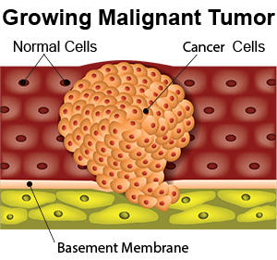
How Cancer Develops
Cancer develops from abnormal cell growth. The abnormal mass of cells grows into a tumor, which may be either benign (non-cancerous) or malignant (cancerous). Benign tumors tend to grow slowly without invading local tissues or spreading to other parts of the body. Malignant tumors, on the other hand, grow rapidly with blood vessels supplying them with the necessary nutrients. Eventually, the malignant tumor will invade healthy tissue, and it may metastasize (spread to other body parts). Normally, a healthy immune system will recognize foreign cells and destroy them. For some unknown reason, the immune system does not destroy tumor cells; they are seen as new tissues. The blood supply provides them with the necessary nutrients to sustain their growth. A weakened immune system may increase your risk of developing tumors, but there is no single known cause of cancer. Malignant tumors are dangerous, and finding and treating them before they spread is important.
The various types of cancer are named for the part of the body in which the tumor forms—not where it has spread or metastasized to. A famous example is Terry Fox (link found on Module 3 main page, tab 06), who had a malignant tumor in a bone in his right leg that metastasized to his lungs. He did not die from lung cancer: he died from bone cancer that had spread to his lungs.
For a good overview of cancer and its development, watch "What Is Cancer?" (link found on Module 3 main page, tab 07) by the Canadian Cancer Society .
"How Do Cancer Cells Behave Differently From Healthy Ones?" (link found on Module 3 main page, tab 08) from George Zaidan explains how cancerous tumors form. This video also addresses treating cancer.
For those who are interested, the optional video "How Does Cancer Spread?" (link found on Module 3 main page, tab 09) from Ivan Seah Yu Jun explains metastasis and the three types of it.
In your learning guide, start to record your notes on cancer now.

The Situation in New Brunswick
According to the Canadian Cancer Society, in 2019, an estimated 5,100 new cases of cancer were diagnosed in New Brunswick, and 2,100 New Brunswickers died of the disease. Every day, an average of 14 people in New Brunswick are diagnosed with cancer and 6 people die of the disease.
When adjusted for the age of the population, New Brunswick has the 4th highest rate of cancer and the 7th highest mortality rate from cancer among the provinces and territories.
Across Canada, breast, lung, prostate and colorectal cancer comprise the majority of new cases. Breast cancer is the most frequently diagnosed cancer in women; for men, it is prostate cancer. However, mortality rates for lung cancers are high throughout the Atlantic provinces and Quebec. These mortality rates reflect past smoking rates in these provinces. Lung cancer remains the leading cause of death from cancer for both men and women in New Brunswick.
The economic burden of cancer is high. It by far exceeds that of any other disease including cardiovascular disease. Everyone pays a price when someone is diagnosed with cancer:
- The government and the individual pay health care expenses.
- The employer pays with lost work time and productivity of the worker.
- The individual and possibly family members lose time from work to help care for the cancer patient.
- The patient has a lowered quality of life and a reduced life span.

In your learning guide, add notes about not only the risk factors for cancer but also the economic costs of cancer now.

Preventing Cancer
Some risk factors provoke the development of cancers. These are known as initiators or carcinogens. Carcinogens are found in heavily smoked, pickled or cured foods. Pesticides may also be carcinogenic. Both smoking and exposure to sun, radiation and pollution have also been linked to an increased risk of cancer.
Promoters help tumors grow once they have started; they may increase their rate of growth. Linoleic acid (Omega-6 fatty acid) may promote cancer growth. It is found in vegetable oils; it is an essential fatty acid.
Antipromoters are the opposite of promoters: they protect against the development of cancer. Omega-3 fatty acid is known to have this effect. It is found in fish oils; it is also an essential fatty acid. Fruits and vegetables are the best known antipromoters.
The Canadian Cancer Society estimates that half of all cancers can be prevented through healthy living and policies that protect the public. One-third of all cancers can be linked to diet, obesity and lack of exercise, and smoking is responsible for 30% of all cancer deaths.
Both the Canadian Cancer Society and the Heart and Stroke Foundation state that "fifteen of the world’s leading researchers in diet and cancer recently reviewed more than 4,500 studies from around the world. Vegetables and fruit came out on top as the foods most likely to reduce the risk of cancer. Researchers recommend that everyone should eat 5 or more servings a day, all year round." Fruits and vegetables contain fibre, nutrients, antioxidants and phytochemicals that help protect against cancer. As we saw during Module 2: Nutrients, antioxidants protect you against free radicals. Phytochemicals help activate enzymes to destroy carcinogens.
The Canadian Cancer Society recommends the following to reduce your risk of cancer:
- Live smoke-free. This preventative step is the single most important thing you can do to decrease your cancer risk, as smoking is responsible for 30% of all cancer deaths and about 85% of all lung cancer cases.
- Increase physical activity. Current research has shown physical activity can reduce the incidence of colorectal cancer and may help to reduce cancers of the breast and prostate. It also helps maintain a healthy body weight, which is important in reducing the risk for many cancers.
- Eat more fibre-containing foods. Researchers believe that fibre dilutes the concentration of cancer-causing substances and also speeds their removal from the body.
- Eat at least five servings of fruit and vegetables every day all year long. (Recall from Module 1: Health and Wellness that Canada's Food Guide recommends that half of your plate at every meal be comprised of vegetables and fruits.)
- Keep your body mass close to ideal. People who are 40% or more above ideal mass have a 50% higher risk of cancer.
- Limit alcohol consumption. Drinking 3.5 alcoholic drinks a day doubles or even triples your risk of cancer of the mouth, esophagus, larynx and pharynx. The risk increases dramatically if the person smokes as well. Drinking can also increase your risk of liver, breast and colorectal cancer.
- Minimize your consumption of smoked, nitrate-cured and salted foods. Red meat and processed meats have been linked to increased risks of colorectal center. Moreover, excessive intake of salt has been linked to an increased risk of stomach cancer.
- Reduce your exposure to Ultraviolet (UV) rays from the sun or tanning beds to decrease your risk of skin cancer.
- Be familiar with your body and report any changes to your healthcare professional.
- Handle hazardous materials safety and according to instructions.

The interactive video "It’s My Life! Stop Cancer Before it Starts" (link found on Module 3 main page, tab 10) gives many tips for prevention of cancer.
In your learning guide, complete the section "Preventing Cancer".

Cardiovascular Disease
Cardiovascular disease includes a collection of diseases and injuries to the cardiovascular system—the heart, the blood vessels of the heart, and the system of blood vessels (arteries and veins) throughout the body and brain:
Coronary artery disease refers to conditions affecting the coronary arteries – the blood vessels that supply oxygen-rich blood to the heart itself. Coronary artery disease is the most common of the cardiovascular diseases, and it causes the most deaths.
Atherosclerosis is caused by a build-up of plaque along the walls of the arteries. As more plaque attaches to the artery walls, the blood flow becomes restricted, and eventually, a complete blockage can form. When blood supply to areas of the body is restricted, that part of the body is robbed of nutrients and oxygen.
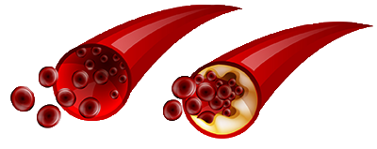
Depending on which arteries are affected, different results occur. When the coronary arteries are blocked, this is coronary artery disease. This condition restricts blood flow to the heart muscle, which can cause either pain around the heart area (angina) or the death of some heart cells (a heart attack). If the blood supply to the brain is blocked, a stroke occurs.
The risk factors for atherosclerosis include the following:
- high blood pressure.
- high blood cholesterol.
- diabetes.
- obesity.
- a diet high in saturated and trans fats.
- a family history of heart disease.

Hypertension is an increase in blood pressure in your arteries, and this condition causes your heart to work harder than normal to pump blood through your blood vessels. It contributes to over a million heart attacks and over one half million strokes each year. Your heart beats on average 70 times per minute with a half second rest between beats. This action pumps blood into the arteries at a rate of about 70 ml per beat with a pressure of 120 mmHg. This flow may increase up to six times this amount with exercise. The resting heart has a normal range of 50 to 100 beats/minute with the average resting rate of 70 beats/minute for males and 75 beats/minute for females. Your resting heart rate may vary because of heredity, sex, fitness level, stress, or other medical conditions. Recent studies have indicated that a resting heart rate of 80 or more increases your risk of dying within ten years because of cardiovascular disease. The majority of people who experience a high resting heart rate are those who smoke, drink coffee, are overweight and out of shape, and are exposed to constant stress situations.
When blood flow is restricted, the heart muscle must work harder and increase the pressure to pump the blood through the body. As blood pressure increases to pump the blood through the restricted arteries, it causes more damage to the artery walls. Fatty deposits and clots have a tendency to form where the damage occurs. Constant elevated blood pressure may cause an artery to dilate or balloon to form an aneurysm, which can eventually even burst!
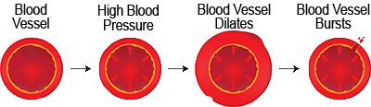
The higher blood pressure is above normal, the greater the risk of atherosclerosis. High blood pressure (hypertension) and atherosclerosis together form a life-threatening combination. Strain on the heart can enlarge or weaken it, either of which can cause heart failure. An undetected aneurysm can result in massive bleeding and death.
Stroke is caused by a blockage of blood flow to the brain; strokes cause brain damage.
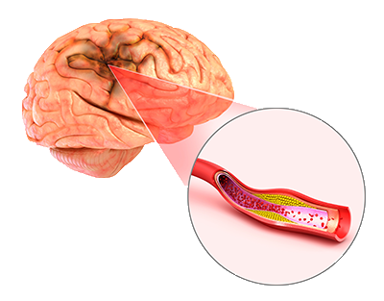
Heart attack happens when blood flow is interrupted to the heart. Heart attacks may damage the heart muscle.
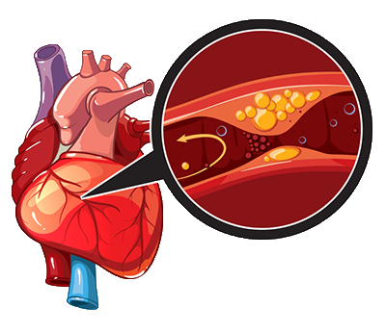

In 2018, diseases of the heart were the second-leading cause of death in Canada while cerebrovascular diseases (diseases of the blood vessels and blood supply to the brain) were the third leading cause of death in Canada. The Public Health Agency of Canada's Canadian Chronic Disease Surveillance System (CCDSS) indicates that 2.4 million adult Canadians have been diagnosed with heart disease. In 2018, Stats Canada reported 53,134 deaths in Canada because of heart disease and 13,480 deaths from cerebrovascular disease. They also reported 19% of all deaths in Canada in 2018 were due to heart diseases.
According to reports by the World Health Organization (WHO), cardiovascular diseases are the leading cause of death globally/ In 2016, an estimated 17.9 million people worldwide died from cardiovascular diseases, 31% of all deaths that year. Of these deaths, the vast majority (85%) were due to heart attack and stroke. There is strong scientific evidence indicating that the major portion of these deaths could be prevented with changes in dietary habits and lifestyle. In 2002, the World Health Assembly began developing a worldwide plan to improve the population’s diet, physical activity and health.
As with other chronic conditions, cardiovascular diseases develop over a long period of time. Some of the trouble begins in childhood with poor dietary habits and lack of physical activity.
For a good overview of heart attacks, watch "What Happens During a Heart Attack?" (link found on Module 3 main page, tab 11) by Krishna Sudhir. The video includes prevention.
This video from Wilfred Manzano on “How Blood Pressure Works” (link found on Module 3 main page, tab 12) helps explain blood pressure and atherosclerosis.
In your learning guide, note the different types of cardiovascular disease now.

Risk Factors for Cardiovascular Disease
Several factors affecting your sitting heart rate, and the higher your sitting heart rate, the higher your risk of cardiovascular disease:
- Age: Although our maximum heart rate decreases as we age, the rate of the heart at rest normally remains fairly stable.
- Sex: Males usually have a lower heart rate than females.
- Fitness level: The better your physical condition, the lower your resting heart rate. A person in top physical condition may have a resting heartbeat of 50 beats/minute. When you exercise, you force your heart to work harder for short periods so that it finds normal daily work easier in comparison.
- Body temperature: The heart rate increases an average of 20 beats/minute for every 1°C above the normal body temperature of 37°C.
- Sleep: Your heart rate lowers while you sleep.
- Smoking: Smoking triggers a higher heart rate because of carbon monoxide in the cigarette smoke.
- Caffeine: Caffeine stimulates the heart rate to beat faster. Excessive caffeine can even provoke heart attacks!
- Environmental temperature: Heat and humidity will increase a normal or resting heart rate. Cold temperatures will lower heart rates.
- Obesity: Added adipose tissue is supplied by extra blood vessels and capillaries, and the heart has to work harder to pump blood through a longer system.
- Reduced blood flow to kidneys: Kidneys respond by increasing blood pressure by expanding blood volume and constricting the surrounding blood vessels.
- Diabetes: High blood pressure is 2–3 times more common in people who have Type II diabetes. High blood insulin triggers the kidneys to retain sodium, and this sodium, in turn, increases blood pressure.
In addition to an increased heart rate, there are several other risk factors for cardiovascular disease:
- Sex: Males normally have higher blood cholesterol than females who are under the age of 45–50. Menopause increases the risk for women.
- Age: Cardiovascular disease develops over time; therefore, risk increases with age.
- Family history: A family history of heart disease increases your risk.
- Smoking: To reiterate, the inhaled carbon monoxide in cigarette smoke increases your heart rate. Additionally, smoking damages the arteries and heart. Smoking decreases the level of HDL in the blood.
- Physical inactivity: Physical inactivity increases your risk of high blood pressure and obesity.
- Dietary habits: A diet high in fats causes abnormal blood lipids—high LDL and low HDL. A diet high in sodium causes hypertension. Elevated blood insulin levels trigger the kidneys to retain sodium; this, in turn, increases blood pressure.
- Obesity: A Body Mass Index (BMI) of 18.5–24.0 is desirable. Obesity is a risk factor of many chronic conditions, including cardiovascular disease.

Lifestyle Considerations for Preventing Cardiovascular Disease
In addition to avoiding smoking and increasing your levels of physical fitness, you can also alter your diet to reduce your risk of cardiovascular disease:
- Monitor and control your blood cholesterol.
- Maintain a healthy BMI.
- Reduce the fat, especially the saturated and trans fats, in your diet.
- Replace saturated fats with Omega-3 fatty acids (primarily from fish) to improve the HDL-LDL blood cholesterol ratio.
- Consume a variety of fruit, vegetables and whole grains to trap and excrete fatty acids.
- Monitor and control your blood pressure.
- Reduce your intake of salt.
- For adults over 50, imbibe in moderate alcohol consumption for a pair of heart health benefits (increased HDL and prevention of the formation of blood clots).
Note: Alcohol consumption comes with negative health effects that must also be considered.
- Ensure sufficient intake of micronutrients such as vitamin B9—folic acid, vitamin B6—pyridoxine, vitamin B12—cobalamin, and vitamin E that help protect people from cardiovascular disease.
- Include soy in your diet. Soy (protein and isoflavones) help improve HDL-LDL ratio of blood cholesterol.
Recently, a study called Dietary Approaches to Stop Hypertension (DASH) evaluated the effects of diet and salt on blood pressure, and it confirmed Heart and Stroke Foundation and Health Canada advice on dietary effects on cardiovascular health. From the study emerged the DASH diet. It is very similar to Canada’s Food Guide because it also emphasizes not only fruits and vegetables but also low-fat dairy and meat products.
Read the "High Blood Pressure Diet – the DASH Diet" ” (link found on Module 3 main page, tab 13) by Gloria Tsang for the benefits of the DASH diet.
In your learning guide, add your notes about the dietary considerations for preventing cardiovascular disease now.

Diabetes
Diabetes is a disorder in which the pancreas does not produce enough insulin or the body does not properly use the insulin it does produce. Your body converts carbohydrates to glucose for energy. Metabolizing glucose requires insulin, a hormone produced by the pancreas. Insulin moves glucose from your bloodstream to the body cells where it is needed for energy.
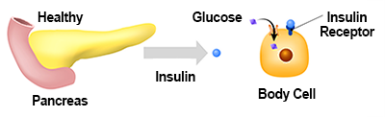
Sometimes, the pancreas does not produce enough insulin, or the body does not use it effectively. Without insulin, glucose levels increase dramatically in the blood and urine. This condition is called diabetes. If untreated, it can cause a variety of serious complications, such as heart disease, stroke, blindness, kidney disease, gangrene, or impotence.
In 2017, roughly 7.3% of all Canadians (2.3 million people) had been diagnosed with diabetes. A study by Health Promotion and Chronic Disease Prevention in Canada estimates that diabetes costs the Canadian health care system $1.5 billion annually. The majority of the cases are Type II diabetes or "adult onset" diabetes, and a significant number of people with diabetes are unaware that they even have the disease. In 2018, diabetes was the seventh leading cause of death in Canada. It accounts for almost 7,000 deaths per year and may be a contributing factor in as many as 25,000 deaths. People who have a history of diabetes in their families have an increased risk of inheriting the tendency to get diabetes.
- Type I, also called juvenile diabetes or insulin dependent diabetes.
Type I occurs when the insulin-producing cells of the pancreas have been damaged or destroyed. The body produces little or no insulin. It is more likely to occur in children or young adults. The onset is sudden, and the symptoms are often severe. A person with this type of diabetes requires daily insulin injections or a pump. Insulin is not a cure—it is a means of managing diabetes. There is no cure.
The cause of Type I diabetes remains unclear. There is a genetic component, though, as having a family member with Type I diabetes increases your risk.
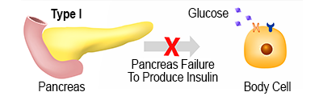
- Type II, also called adult onset or maturity onset diabetes.
Type II diabetes—often referred to as "maturity onset" or "adult onset" diabetes—is most common in people over 45 years old. Still, it is increasingly common in younger populations—it can affect children and teenagers. According to Health Canada, this type of diabetes accounts for 90% of all diabetes cases. The body produces insulin, but it is unable to use it effectively. This type may take months or even years to develop, and symptoms are often mild or do not show. Often a person with Type II diabetes experiences recurring gum or bladder infections, cuts and bruises that are slow to heal, drowsiness, and tingling or numbness in the hands or feet. Other symptoms, such as increased urination, thirst, fatigue, and unexplained weight loss, may occur as well. If symptoms are mild, lifestyle changes to improve diet and exercise might be enough to control blood sugar levels. More severe cases may require oral medications or insulin injections to control blood sugar levels. Approximately 20% of diabetics who have Type II need insulin injections to control the condition.
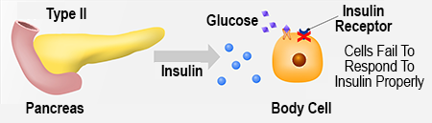
Several risk factors are associated with Type II diabetes:
  - Being over 45
  - Being obese—Diabetes cases are double in people of unhealthy weights compared to those who have a healthy BMI. There is also a higher risk for those who have a tendency to gain the excess weight around the middle section of the body.
  - Having a family history of diabetes
  - Being physically inactive
  - Being of Indigenous, African, Hispanic or Asian descent
  - Giving birth to babies over 4.0 kg (9 lbs)
  - Being previously diagnosed with impaired glucose tolerance
  - Having difficulty coping with stress
  - Having a history of hypertension, high cholesterol, or other cardiovascular problems

- Gestational diabetes.
Gestational diabetes is a temporary condition that affects 2–4% of women during pregnancy. The stress of the pregnancy on the mother’s system causes the pancreas to produce insufficient insulin or the body to use the insulin ineffectively, and the expectant mother then suffers from high blood glucose. Treatment may involve adjusting the diet, increasing exercise and sometimes injecting insulin. Once the baby is born, blood glucose levels return to normal although 30–40% of women who experience gestational diabetes develop Type II diabetes later in life (within 5–10 years).
For a quick overview of gestational diabetes, watch "Diabetes During Pregnancy: What Is Gestational Diabetes?" by the American Diabetes Association. (link found on Module 3 main page, tab 14)
No matter which type of diabetes you have, you must continually monitor your blood sugar levels and work with your healthcare professional to keep them within the recommended range. Some incidences of Type II and gestational diabetes can be managed through diet and exercise alone. In other instances, oral medications or insulin injections are combined with diet and exercise to control blood sugar levels. All people with Type I diabetes require insulin. After you reach age 45, you should be tested for Type II diabetes every 3 years. If you exhibit any risk factors other than age, you should be checked yearly.
For an overview of diabetes—and an interesting account of its discovery in history, watch "What Did Dogs Teach Humans About Diabetes?" (link found on Module 3 main page, tab 15) by Duncan C. Ferguson. Watch as well "What Does the Pancreas Do?" (link found on Module 3 main page, tab 16) by Emma Bryce for an explanation of the pancreas's key role in regulating blood sugars and in digestion.
In your learning guide, add your notes about the three types of diabetes now.

Lifestyle Considerations for Preventing and Managing Diabetes
Obesity plays a major role in the development and progression of Type II diabetes. Achieving and maintaining a healthy weight and engaging in regular physical activities can help to reduce the risk of developing Type II diabetes by as much as 50%. In addition to following the guidelines in Canada's Food Guide and sticking to a healthy diet, you should also accumulate one hour of physical activity each day to stay healthy or to improve your health. If you engage in moderate exercise, you can reduce the amount to 30 minutes per day, 4 days per week. Find an activity you enjoy and you stick with; walking is an excellent start. You do not need to go to expensive health and fitness clubs to benefit from physical activity.
Healthy eating habits for diabetics are much the same as those of anyone who wishes to remain healthy. Eat regular meals three times a day to distribute energy intake over the day. Pay attention to the quantity and quality of the food you eat. Remember that carbohydrates with high GI ratings are quickly broken down into glucose in the body; therefore, watching how many carbohydrates with high GI ratings you eat is important in controlling the amount of glucose in your blood. High fiber foods may help lower blood glucose levels by slowing down digestion. Spreading your daily requirement of carbohydrate over the day (and not eating too much in one meal) is important to help maintain a constant blood glucose level instead of having extreme highs and lows.
Limit foods high in concentrated sugar because they have little nutritional value and cause blood glucose levels to rise. Choose a variety from all of the food groups in Canada's Food Guide. Include snacks between meals especially if your energy expenditure is greater than usual or if you are taking medication or injections for diabetes. A healthy balanced diet, spread evenly over the day, may help to reduce the amount of diabetes medications you need.
In your learning guide, add your notes about minimizing your risk of diabetes now.

Osteoporosis
"Osteoporosis" means porous bones. It is characterized by low bone mass and deteriorating bone tissue, both of which lead to an increase in fragile bones and risk of fracture, particularly of the hip, spine and wrist. Health Canada and the Osteoporosis Society of Canada report that 2 million Canadians are affected by osteoporosis. There are no warning signs until bones begin to fracture easily. One day, you may be trying to open a jar, and you fracture your wrist, or you cough and fracture a rib. Approximately one in three women and one in five men will suffer a bone fracture because of osteoporosis in their lifetime. Over eighty percent of all fractures in people over 50 are believed to be because of osteoporosis. Severe cases of this disease result in disfigurement, reduced height, reduced mobility, and loss of independence. Besides the human cost, there are economic costs, as well. The Osteoporosis Society of Canada estimates that as of 2010, our health care system spends $2.3 billion annually on treating osteoporosis and the fractures it causes. Because of our aging population, this figure has likely already increased and will continue to increase more still.
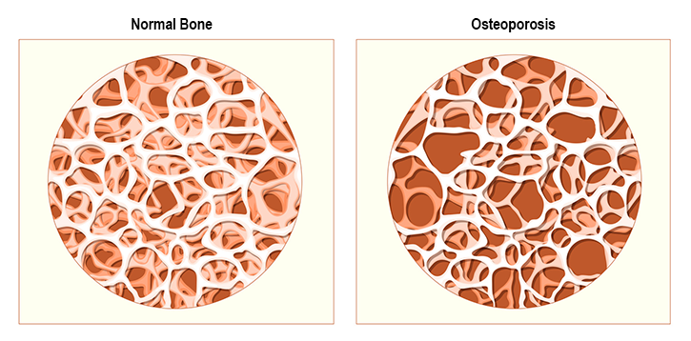

The Development of Osteoporosis
The majority of cases of osteoporosis are due to reduced bone mass caused by low levels of calcium, phosphorus and other minerals in the bones. It may also be a result of endocrine disorders or excessive use of corticosteroids or some other medications. The disease sets in during the later years of life, but it starts to develop much earlier.
Throughout your life, your bones are constantly replacing old bone tissue with new bone tissue. In the early years of your life, your bone mass increases with peak bone mass being achieved by age 20 for women and by 25 for men. As you continue to age past these years, bone tissue is not renewed as quickly as it once was, and you begin to lose bone mass. Retaining as much of this bone mass as possible through a healthy diet and an active lifestyle is important. If you don't, you begin to lose bone mass, and your bones begin to weaken. The early stages of the disease often do not cause any pain or symptoms. You can lose bone mass steadily over many years without noticing any changes in your health. As the disease progresses, you may experience back pain; reduced height (because of stooping caused by a weaken spinal column); and fractures of the vertebrae, wrists, hips or other bones. Once these symptoms appear, the disease is fairly well advanced. A diagnosis is made by assessing your risk and measuring your bone density. The early detection of bone loss is critical to preventing fractures. There is no cure for this disease; prevention is the key.
For an overview of this chronic condition, watch "Osteoporosis" (link found on Module 3 main page, tab 17) by MedlinePlus.
In your learning guide, define "osteoporosis" now.

Risk Factors for Developing Osteoporosis
Developing osteoporosis seems to depend partly on genetics and partly on other factors, including nutrition. Age and sex are the strongest indicators of risk with one in four women over 50 years old developing osteoporosis and one in two women over 70 years old being affected. The risk is double for women compared to men until age 75 when the risk evens out for those sexes.
Other risk factors include:
- family history—You are at increased risk if a parent or sibling has had the disease or if there is a family history of fractures.
- spinal fractures or fractures from minor impact after age 40.
- long term low calcium intake or conditions that cause poor calcium absorption—A lack of vitamin D can reduce calcium absorption.
- removal of ovaries or early menopause (before age 45)—When ovaries do not produce estrogen, the rate of bone loss increases.
- low levels of testosterone in men.
- excessive use of some medications, such as corticosteroids (cortisone and prednisone), thyroid medications, heparin, cancer fighting medications and anti-convulsion medications.
- ethnic background—The greatest risk is for whites and South Asians. (Black and Hispanic men and women have a lower risk.)
- body frame size—Small, slender bones are at higher risk because of low initial bone mass.
- osteopenia—This is low bone mass as shown in X-rays.
- smoking.
- excessive caffeine (more than four cups per day of beverages containing caffeine).
- chronic alcoholism (highest risk factor in men)—Having more than two drinks per day on a regular basis reduces bone formation and interferes with calcium absorption.
- diuretics—Some diuretics cause your kidneys to excrete more calcium.
- eating disorders—These may result in low bone density.
- physical inactivity—Physically active young people have the greatest bone density (Weight bearing exercises, such as walking, jogging, hopping and skipping are beneficial for keeping bones strong).
- depression—This mental illness may increase the rate of bone loss in some people.
In your learning guide, record the risk factors for osteoporosis now.

Lifestyle Considerations for Preventing Osteoporosis
The best ways to prevent osteoporosis are to get your daily requirement of calcium and vitamin D and to stay physically active. These steps can also help slow the progression of the disease.

Calcium and Vitamin D

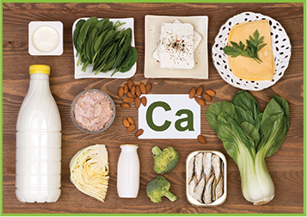
As you age, your calcium requirement and your body’s ability to absorb it change. The average Recommended Dietary Allowance (RDA) for young adults is 1000 mg/day and 1200 mg/day for older adults. This increase in intake with age is a result of the bone density losses associated with normal aging.
Incorporating calcium-rich foods in your diet is important. The dietary sources of calcium include dairy products, broccoli, canned salmon and foods fortified with calcium.
Getting your requirement of vitamin D is important to help your body absorb the calcium. Vitamin D occurs naturally in just a few foods including fatty fish, egg yolks and beef liver. Moreover, certain foods are fortified with vitamin D including milk and margarine. However, sunshine is an excellent source; with exposure to sunshine, our bodies can produce vitamin D. Unfortunately, our exposure to the sun is often limited by the weather, the amount of daylight hours, and concerns about exposing skin to UV radiation, and therefore supplements may be needed. Supplements of calcium with vitamin D added are available, and these are most effective if taken in divided doses with food. If you are taking medications that may interfere with the absorption of calcium, you might also need to supplement this mineral. Supplementing is only recommended when your calcium intake is insufficient; otherwise, there may be other risks to your health.

Physical Activity
Regular physical activity, especially weight-bearing exercise such as walking, jogging, dancing, and so on, can improve bone strength. Other types of exercise can improve balance and coordination to reduce bumps and falls. You’ll gain the most benefit from exercise if you start young and continue throughout your lifetime!

Other Prevention Strategies
Preventing the development of osteoporosis should also include avoiding smoking, excessive caffeine (more than four cups of coffee per day) and alcohol intake (more than two drinks per day).
Post-menopausal woman should consider hormone replacement therapy to reduce the risk, but there are other side effects to these treatments.
In your learning guide, record the prevention strategies for osteoporosis now.

Obesity
More than one billion adults worldwide are overweight, and at least 300 million of these are clinically obese according to the WHO. The WHO considers obesity to be a global epidemic. According to a 2014 Statistics Canada survey, 61.8% of men and 46.2% of women have an increased health risk because of excess weight with 40.0% of men and 27.5% of women classified as overweight and 21.8% of men and 18.7% of women classified as obese. The situation is even worse in New Brunswick, where 26.4% of adults are obese compared to the national average of 20.2%. In 1997, obesity claimed 2.4 % of the health care budget, a total of $1.8 billion. Obesity can cause serious health problems and contributes to several other chronic conditions. The Canadian Cancer Society suggests that 35% of North Americans are obese, and if we were to reduce our body weight by 5–10%, we would see significant health benefits. This reduction may eliminate 40–70% of high blood pressure cases, 50% of high cholesterol cases and 85% of adult diabetes cases.
Obesity is also a major problem with children, with statistics showing 37% of Canadian children either overweight or obese. In 2000, the Canadian Medical Association Journal reported the rate of obesity among Canadian boys aged 7–13 tripled between 1981 and 1996; the rate for girls of the same age group doubled. According to the National Institute of Nutrition, children are 80% more likely to be obese if both parents are obese. Therefore, obesity likely begins at home; it is due to a combination of genetic and lifestyle factors.
Obesity means excessive body fat. It is the result of the people consuming more energy than their body uses. There are five common measures to assess obesity and its associated health risks:

- Body Mass Index (BMI)
BMI is currently the most widely used measurement tool of healthy weights. It is based on a ratio between height and weight, and it serves as a quick way for most adults to estimate their body fat. The calculations are not always accurate for several groups:
  - children, as children’s body fat percentages change as they grow.
  - muscular athletes, as the extra weight from muscle can raise overall weights and trigger high BMIs that overestimate the amount of extra fat.
  - pregnant women, as the extra weight from growing babies can raise overall weights and trigger high BMIs that overestimate the amount of extra fat.
  - the elderly, as decreased bone mass can lower overall weights and lower BMIs that underestimate the amount of extra fat.
People deemed overweight are those with a BMI of 25–29.9. Those with a BMI over 30 are considered obese. Healthy weights fall between 18.5 and 24.9. You are considered underweight if your BMI is less than 18.5. High BMIs have been associated with an increased risk of diabetes, cardiovascular disease and certain cancers.
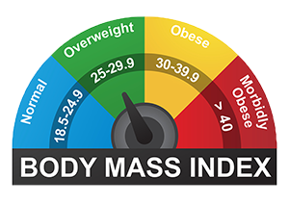
- Body shape
Body shape—the distribution of body fat—can negatively affect health. Abdominal fat is associated with an increased risk of disease. Women whose waist circumference is over 80 cm (31.5 inches) and men whose waist circumference is over 94 cm (37 inches) may have health concerns associated with weight. Women whose waist is greater than 89 cm (35 inches) and men whose waist is greater than 101.5 cm (40 inches) have shown increased risk of heart disease and diabetes.
Fat distribution can also be measured in a ratio between the waist and hip measurements; the lower the ratio, the better. There is a sharp increase in the risk of heart disease in women whose ratio is greater than 0.8 and men whose ratio is greater than 1.0. Excess fat around the hip, thigh and buttock area is often referred to as the "pear shape" figure. Excess fat around the waist is known as the "apple shape" figure. Evidence also suggests that the "apple shape" figure (excessive weight around the middle compared to other areas of the body) is a stronger predictor of health problems than the BMI or waist circumference measurements alone.
To determine your ratio, take your waist and hip measurements and then divide your waist measurement by your hip measurement.
For example, consider someone with a waist that is 28 inches and hips that are 34 inches:
28 ÷ 34 = 0.82 ratio
This is slightly over the risk level for women and under for men.
Try it yourself! Calculate your own waist–hip ratio.
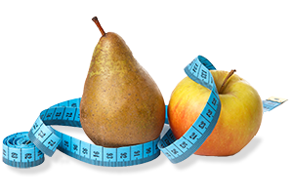
- Anthropometry
Anthropometry (fat fold measure) is measuring the skin fold thickness in various areas of the body, including the triceps, shoulder blades and hips. The triceps skin fold measurement is often referred to as the "TSF." This measurement is useful to determine how much weight is due to muscle versus fat. Pinch these areas on your body and determine the size of the skin fold. A large skin fold is excess body fat. If the skin fold is small, tissue is more muscular than fatty.

- Hydro-densitometry
Hydro-densitometry is measuring body density by taking your weight twice—first while on land and second while submerged in water. You take the difference between the two weights and account for the properties of water to calculate body density. This density measurement can then be used to estimate body composition, including the percentage of body fat.
- Bioelectrical impedance
Bioelectrical impedance can also reveal excessive body fat. Resistance to a low-density electrical current is low in persons who have lean tissue. The measure of resistance is used in a mathematical equation to determine the amount of body fat.
For more on the obesity, watch "What is Obesity?" (link found on Module 3 main page, tab 18) by Mia Nacamulli.
In your learning guide, begin your notes on obesity now.

Development of Body Fat
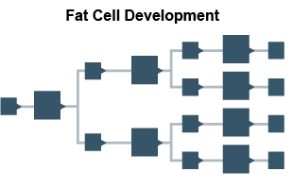
This diagram illustrates the increase in size and number of fat cells as a person continues to consume more food energy than the body uses.
When you consume more kcal than your body requires, the excess energy is stored in the fat cells of adipose tissue. The amount of fat a person accumulates is reflected in not only the number of fat cells but also the size of these cells. Some people are born with more fat cells than others. In late childhood and early puberty, the number of fat cells increases more rapidly in obese children than in children of normal body size. A thirteen-year-old obese child may have as many fat cells accumulated as an adult of normal weight. When you consume more kcal than your body needs, the fats cells fill. Once the cell fills, it divides in two, and each new fat cell fills. This process continues as long as you consume more food than the body needs. When the body calls on the fat storage for extra kcalories, such as when your food supply decreases or when you diet, the fat cells shrink in size, but they do not decrease in number.
This may be the reason why it can be easy to regain weight after dieting. Another reason may be the "set point" theory. Our body is biologically programmed to maintain constants in internal temperature, blood pH, blood glucose, heart rate, and so on. This concept is called "homeostasis" in biology. Researchers have confirmed that after weight gains or losses, the body adjusts its metabolic rate so as to restore the original weight of the person. Energy expenditure increases after weight gain and decreases after weight loss. These changes differ from the body’s natural "set point." This may be why it is difficult for an underweight person to maintain weight gains and an overweight weight person to maintain weight losses.
In your learning guide, note how body fat develops now.

Causes of Obesity

Genetics
Scientists are beginning to study the possibility of an inherited tendency toward obesity. They have recently identified a gene called the Obesity (OB) gene. This gene determines the initial quantity of fat cells and the codes for the protein leptin. Leptin is released by fat cells and acts as a hormone, mainly in the part of the brain called the hypothalamus. Early research suggests that leptin promotes a negative energy balance by suppressing appetite and increasing energy expenditure.
When the body loses fat, the decrease in leptin shifts energy balance toward the positive: eating more and expending less energy. When the body gains fat, leptin increases to shift energy balance toward the negative; the increased level of leptin signals to your body to eat less and use more energy.
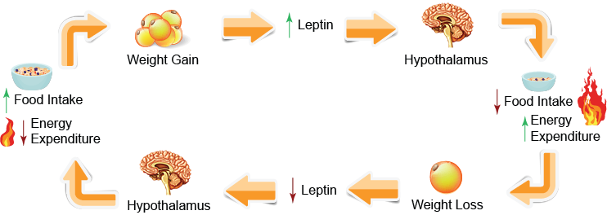
Such a scenario would ensure that all of the fat you gained would be followed by losses to maintain a balance, but this is not the case with obesity. Most obese people have high levels of leptin, but their energy balance does not automatically shift to the negative. Therefore, a resistance to leptin might be a root cause of obesity.
Someday, injections of leptin might even be used to control obesity in genetically obese people, just as insulin is used to control diabetes in insulin-dependent diabetics.
In your learning guide, record your notes about the genetic causes of obesity now.

Causes of Obesity (continued)

Proteins and Hormones
Insulin is a hormone produced by the pancreas to stimulate the glucose circulating in the blood to enter the cells of the body. Excess glucose is then converted to glycogen for storage. In addition, insulin stimulates fat, muscle and liver cells that have absorbed fatty acids from the blood to convert these into fat molecules for storage.
Resistin is a newly discovered hormone, and it is produced by fat cells. It may affect the activity of insulin in the body and may have something to do with the relationship of obesity to Type II diabetes.
Recent research has discovered proteins that are controlled by leptin and regulate food consumption; other proteins regulate genes that control fat cell formation. Other chemicals produced in the brain, digestive juices, and intestines are being investigated as possible pieces to this puzzle. Obesity and its causes are major concerns to health professionals and researchers, and research continues to investigate the genetic relationship to obesity. They believe that genetics may account for 70–80% of obesity cases.

Positive Energy Balances
As we have seen, the interplay between metabolism (energy burned) and eating (energy consumed) can lead to weight gain:
- overeating.
Do you remember from Module 2: Nutrients how many extra kcal are required, in theory, for a weight gain of one pound? (We say "in theory" because as you have just learned about energy balance, the body’s metabolism adjusts to changes in body fat, so weight gain and weight loss is not as straight forward as it first appears.)
For every 3,500 kcal you consume above your daily energy requirement, in theory, you will gain 1 pound (454 g) of body weight. For example, if you consume an extra 500 kcal per day, you will gain approximately 1 pound per week:
500 kcal x 7 day = 3500 kcal
Enough food is produced in the US to supply every human with an average of 3800 kcal/day; this is far more than is required. Foods high in fat and sugar are also abundant in our diets, and these are high calorie foods.
Our busy and sometime sedentary lifestyles often provide us with a tendency to increase our use of fast foods (prepackaged processed foods ready to eat at home or foods from restaurants and fast food franchises). Often we use the excuse we are too busy or too lazy to prepare healthy meals for ourselves.
Sometimes we eat to comfort ourselves or because we are bored. The choices we make are often the high calorie choices. Binge eating may cause a person to consume thousands of calories in one feast. About 30% of obese people are binge eaters.
- slow metabolism.
There are several conditions that may slow your metabolic rate—the rate at which food is turned into energy:
  - Physical inactivity:
    - Metabolism slows without physical activity. Regular exercise improves metabolism.
  - Aging:
    - As we age, our base metabolic rate (metabolism at rest) slows; therefore, even an adult who maintains normal eating habits and a healthy activity level will most likely gain weight over time. Adults gain an average of ½ lb/year between ages 25–55.
  - Smoking:
    - Nicotine increases metabolism—at a horrible, horrible cost—and if you quit smoking, your metabolic rate slows. This often leads to weight gain even without an increase in food, and ex-smokers often snack instead of smoking, which increases the kcal intake as well.

Medical Conditions that May Cause Obesity
In addition to the causes of obesity we've already seen on this screen, several types of medical conditions can lead to obesity:
- Thyroid issues, which occur when the thyroid gland does not produce sufficient thyroxin, the hormone that controls metabolism, and the metabolic rate slows.
- Genetic disorders:
  - Froehlich’s syndrome in boys.
  - Laurence-Moon-Biedl.
  - Prader-Willi Syndrome.
- Hypothalamic obesity, which is caused by an injury to the hypothalamus.
- Cushing’s Disease, which causes the release of high levels of steroid hormone.
- Polycystic ovarian syndrome, which is a common hormonal disorder in women.
We won't be exploring these diseases in greater detail here, but generally, these are genetic diseases that vary from altering a sufferer's metabolism to increasing a sufferer's appetite.
For those who are interested in Prader-Willi Syndrome, watch the optional video "Living with Prader-Willi Syndrome" (link found on Module 3 main page, tab 19) by Abbott Philson.

Medications
Some medications may cause a gain in weight due to retention of body fluid or increased appetite, including:
- corticosteroids.
- some oral contraceptives (usually temporary).
- cancer treating drugs (progestins).
- insulin or insulin-stimulating drugs.
- anti-seizure agents used to treat epilepsy and bipolar disorders.
- some antipsychotics.
In your learning guide, record your notes about these causes of obesity now.

Health Risks of Obesity
Obesity can cause serious health problems. One report warns that almost one-third of adult Canadians risk disability and premature death because of unhealthy weights. Obesity is related to several chronic health conditions; it is threatening the health of a growing number of adults and children.
Excessive body fat puts strain on body organs:
- The bones must support more weight than they should. This can lead to problems with bones and joints, such as osteoarthritis, and can eventually lead to joint replacement surgery.
- The heart must beat more often to supply the excess fat cells with oxygen. This causes an increase in blood pressure and often damage to blood vessels. Studies have shown a significant increase in the risk of cardiovascular disease in a person with a BMI above 27. The risk increased slightly in persons with BMIs between 25 and 27. Heart disease is the number one cause of death in obese people. Obese persons have almost three times the risk of heart disease as persons of normal weight.
- The pancreas must produce more insulin to regulate blood glucose levels. This may cause Type II diabetes.
- High fat diets increase the risk of high cholesterol and some types of cancer.
- Obesity increases the risk of developing gallstones.
- Obesity increases the incidence rate of sleep apnea.
In your learning guide, record your notes about the health risks of obesity now.

Dietary Considerations for Preventing Obesity
To prevent obesity, control weight, and maintain a healthy energy balance, you—and everyone—can benefit from following the following tips:
- Eat a balanced diet including foods from all four food groups to avoid monotony. Try new foods.
- Don’t skip meals, especially breakfast. You often want to snack on unhealthy choices when you skip meals. Breakfast helps boost your metabolism.
- Choose low calorie, nutrient-dense foods more often, especially for snacks.
- Drink water with your meals and often during the day. You won’t feel as hungry as often.
- Choose smaller portions of food during meal times.
- Eat slowly so food has a chance to reach the stomach and signal your brain that you are full. These signals take 20 minutes, so during that time, any additional food you eat is in excess.
- Learn to use herbs and spices instead of salt, sugar and sauces for flavour.
- Do not constantly weigh yourself. You may become discouraged and go back to old habits. Record what you eat, and check your progress once a week. If you are trying to lose weight unsuccessfully, review what you have eaten during the week and make some necessary changes.
- Get moving! Regular exercise boosts your metabolism, and it is important for maintaining a healthy weight. Do something you enjoy.
In your learning guide, record your notes about preventing obesity now.

Eating Disorders
If obesity is the result of being stuck in the positive energy balance for too long, we must also examine being stuck the other way. Eating disorders are a collection of mental health disorders that drive an individual to take the negative energy balance too far for too long.
Everyone eventually has to watch their diet and levels of physical activity to avoid weight gain, and most people get healthier as they exercise and eat better. However, for some people, dieting to lose weight progresses to a dangerous and obsessive point. When low body weight becomes an important goal, people begin to view normal, healthy body weights as being too fat, and they take unhealthy actions to lose weight. There are many causes of this dangerous obsession with weight loss: sociocultural, psychological and, possibly, neurochemical. As an individual focuses intensely on losing weight, their psychological problems worsen, and they become extremely prone to developing eating disorders. Athletes are particularly susceptible to developing eating disorders.
We will examine the two most common eating disorders over the next two screens: anorexia nervosa and bulimia.

Anorexia Nervosa

Anorexia nervosa is one type of eating disorder in an entire spectrum of eating disorders. It is also a psychological disorder and a condition that goes beyond out-of-control dieting. The person initially begins dieting to lose weight, and over time, the person comes to feel mastery and control over their life because of this weight loss. The individual continues the endless cycle of restrictive eating, often to a point close to starvation, to feel a sense of control over the body.
People with anorexia usually lose weight by reducing their total food intake and exercising excessively. They may restrict their intake to fewer than 1000 calories per day (often 750–1000 per day). Most avoid fattening, high-calorie foods and eliminate meats. The diet of persons with anorexia may consist almost completely of low-calorie vegetables like lettuce and carrots or popcorn.
Read the "Anorexia Nervosa Fact Sheet" (link found on Module 3 main page, tab 20) by the National Alliance on Mental Illness (NAMI) for more information on this chronic condition. Warning: You should expect to be assessed on this content.
For an optional look at unhealthy body images, watch "The Beauty Myth" (link found on Module 3 main page, tab 21) by Naomi Wolf. She explains the core concept of her 1991 book of the same name in this brief video. In that book, she argues that women suffer from unrealistic social expectations of physical beauty. Her brief explanation in this video discusses only heterosexual relationships and only the societal pressure on women's physical appearance.
The most common signs of anorexia nervosa include:
- being preoccupied with food and refusing to maintain minimally normal body weight.
- continually thinking they look fat even when they are bone-thin.
- having nails and hair become brittle and skin become dry and yellow.
- bring depressed.
- complaining of feeling cold (hypothermia) because their body temperature drops.
- forming lanugo (the fine hair typically found on newborns) on their body.

Anorexia can have dangerous effects on all aspects of an individual’s life and physical health:
- Being seriously underweight can lead to depression and social withdrawal. The individual can become irritable and easily upset and have difficulty interacting with others.
- Sleep can become disrupted, and this leads to fatigue during the day. Attention and concentration can decrease. All of these features can negatively affect one’s daily activities.
- Most of the medical complications of anorexia nervosa result from starvation. Few organs are spared the deterioration brought about by anorexia. Generalized muscle loss and weakness are common. Damage to the structure and function of the heart is also possible, and this damage increases the risk of heart failure and death. Although not life-threatening, abnormally slow heart action (bradycardia) and unusually low blood pressure (hypotension) are frequently seen. There may also be disturbances in the heart rate and a reduction in the work capacity of the heart.

- Gastrointestinal complications are also associated with anorexia. Constipation and abdominal pain are the most common symptoms. The rate at which food is absorbed into the body is slowed down. Starvation and overuse of laxatives can seriously disrupt the body’s normal functions involved in the elimination process.
- Disturbances in the menstrual cycle are frequent and can affect not only child-bearing but also bone density growth, which is very important to a woman’s health as she ages. Hormonal imbalances are found in men with anorexia as well. Continual restrictive eating can trick the thyroid into thinking that the body is starving, causing it to slow down in an attempt to preserve calories.
- Anorexics who use a large quantity of laxatives or who frequently vomit are at great risk for dehydration and electrolyte imbalance, which can have life-threatening consequences.
- Physical symptoms, other than the obvious loss of weight, can be seen. Anorexia can cause dry, flaky skin that takes on a yellow tinge. Fine, downy hair grows on the face, back, arms and legs. Despite this new hair growth, loss of hair on the head is not uncommon. Nails can become brittle. Frequent vomiting can erode dental enamel and eventually lead to tooth loss.

Bulimia

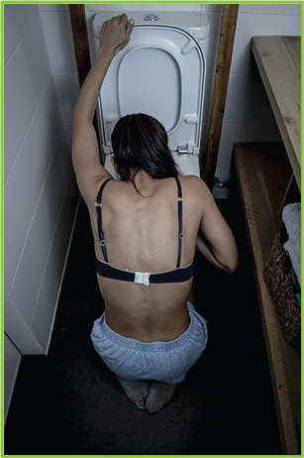
- Bulimia is characterized by episodes of secretive excessive eating (bingeing) followed by inappropriate methods of weight control, such as self-induced vomiting (purging), abuse of laxatives and diuretics, or excessive exercise. Like anorexia, bulimia is a psychological disorder. It is another condition that goes beyond "out-of-control" dieting.
- Bulimia is not as obvious as anorexia, but it is actually more common. Unlike anorexics, bulimics experience significant weight fluctuations, but their weight loss is usually not as severe or as obvious and the recovery rate is felt to be higher; however, many bulimics continue to retain slightly abnormal eating and dieting behaviours even after the recovery period.
- The secrecy of bulimia stems from the shame that bulimics often attach to the disorder. Binge eating is not triggered by intense hunger: rather, it is often a response to depression, stress or other feelings related to body weight, shape or food. At first, binge eating often brings on a feeling of calm or happiness, but self-loathing soon replaces the short-lived euphoria because of the overeating.
- Often, the individual will feel an impairment or loss of control during the binge eating, and the purging becomes a way of regaining control. Not all bulimics engage in self-induced vomiting or the misuse of laxatives, diuretics or enemas during an episode. Some may fast for days following a binge episode while others resort to excessive exercise as a method to regain their control and rid their body of the possible weight gained during the binge.
- As with anorexia, there is currently no definite known cause of bulimia, but it is generally felt to begin with a dissatisfaction of one’s body. The individual may actually be underweight, but when they look in the mirror they see a distorted image and feel heavier than they really are. At first, this distorted body image leads to dieting, and this dieting escalates and can lead to bulimic practices.
There are five basic criteria in the diagnosis of bulimia:
- Recurrent episodes of binge eating. This is characterized by eating within a two-hour period an amount of food that is definitely larger than most people would eat during a similar period of time and under similar circumstances.
- A sense of lack of control over the eating during the episode or a feeling that one cannot stop eating.
- In addition to the binge eating, there is an inappropriate behaviour to prevent weight gain. These behaviours can include self-induced vomiting; misuse of laxatives, diuretics, enemas or other medications; fasting; or excessive exercise.
- Both the binge eating and the compensatory behaviours must occur at least two times per week for three months and must not occur exclusively during episodes of anorexia.
- Finally, the behaviour above is unduly influenced by body image.

The medical complications that result from bulimia are generally due to continual bingeing and purging. The type of purging behaviour used can have varied effects on different body systems:
- Self-induced vomiting can result in oral complications. Repeated exposure to acidic gastric contents can erode tooth enamel, increase dental cavities and create a sensitivity to hot or cold foods. Swelling and soreness in the salivary glands from repeated vomiting can also be a concern.
- The esophagus and the colon are the areas most affected by bulimic behaviours. Repeated vomiting can result in ulcers, ruptures or strictures of the esophagus. Acid that backs up from the stomach (reflux) can also become a problem.
- The misuse of diuretics and laxatives combined can place the bulimic at great risk for electrolyte imbalance, which can have life-threatening consequences.

In your learning guide, record your notes about eating disorders now.

Treatment for Eating Disorders
Patients with anorexia, bulimia, or both (yes, you can have both simultaneously) present a variety of medical and psychological complications, which are usually considered to be reversible through a multidisciplinary treatment approach. Treatment can be managed by a physician, psychiatrist or a clinical psychologist. The extent of the medical complications generally dictates the primary treatment manager. Treatment can include hospitalization for a period of time.
An appropriate treatment approach addresses the underlying issues of control, self-perception, and family dynamics. Nutritional education and behaviour management provides the patient with healthy alternatives to weight management. Group counselling or support groups can assist the patient in the recovery process as well. The ultimate goals are for patients to accept themselves and to lead a physically and emotionally healthy life. Restoring physical and mental health takes time, and the results are gradual. Patience is a very important part of the recovery process.
For more on the suffering from and overcoming eating disorders, watch "After Anorexia: Life's Too Short to Weigh Your Cornflakes" (link found on Module 3 main page, tab 22) by Catherine Pawley. She explains her own history of anorexia nervosa and her recovery.
In your learning guide, record why you think we discussed eating disorders immediately after a discussion of obesity.

Dental and Oral Disease
As we saw in Module 1: Health and Wellness, a risk factor for many diseases is insufficient health maintenance, such as undergoing regular dental check-ups. Visiting your dentist every 6–9 months for dental examinations and cleanings is important in avoiding dental and oral diseases and conditions. If you notice any changes in your oral health, visit your dentist immediately.
Lifestyle risk factors also affect your oral health:
- smoking.
- chewing tobacco.
- poor eating habits.
- poor oral hygiene.
Smoking and chewing tobacco increase your risk of oral cancers. Poor eating habits and improper oral hygiene increase your risk of cavities and gum disease.
- plaque.
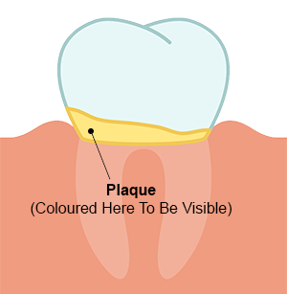
Dental plaque is an invisible, sticky film of bacteria that forms on teeth, especially along the gum line. As food is digested, bacteria in your mouth feed on sugars and produce acid as a by-product for 20–30 minutes after you finishing eating. Depending on the type of food you eat and how often you eat it, brushing using fluoride toothpaste at least twice each day will help to remove this plaque from accessible areas. Foods that are sweet and sticky stay on the teeth longer and result in more plaque than foods that are not chewy and do not remain in the mouth for a long time. If you are going to eat chewy candy, eating it all at once is better than eating it slowly over a period of time. For example, eating a handful of candy within 5 minutes exposes your teeth for approximately 35 minutes. Eating one at a time over 2 hours exposes your teeth continuously for more than 2.5 hours. More plaque has a chance of forming along the gum line.

- calculus.
Calculus—no, not that kind!—is hardened plaque. It forms when minerals from your saliva are deposited on and around the bacteria in plaque. Even though this kills the bacteria, the rough and hardened surface it leaves behind is ideal for even more plaque formation. It is not easily removed: dentists use special instruments to clean calculus during your regular dental appointments.
To minimize the formation of calculus—and it can really add up—you must emphasize flossing between teeth to remove plaque and food particles that may have become lodged between the teeth. Flossing is important to keep gums healthy.
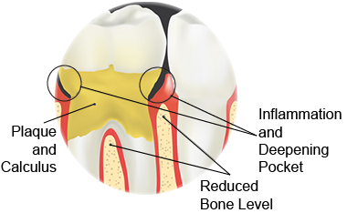
- cavities.
Plaque and calculus on teeth that is not removed can cause cavities—deterioration of the enamel—the outmost layer of the tooth. If cavities are not treated (filled), they may cause infection within the tooth and gum, as bacteria enter the cavity—the breach in the perimeter defenses of the tooth.
Watch "What Causes Cavities?" (link found on Module 3 main page, tab 23) by Mel Rosenberg for more detail on cavities, including
explanations of the link between sugar and cavities and the role of microbes in cavity formation.
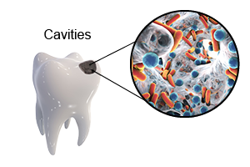

- gingivitis.
Gingivitis is a gum disease characterized by red, swollen and tender gums. The gums have a tendency to bleed easily when they are infected.
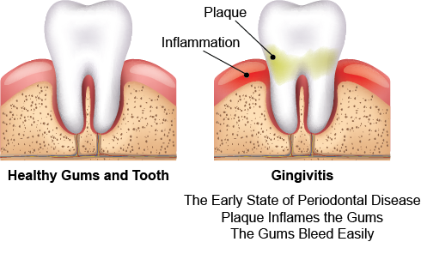
- periodontal disease.
You may consider these forms of dental and oral conditions stages in a process—a deterioration. If plaque, calculus and gingivitis are left untreated, the teeth deteriorate into periodontal disease. The gums and supporting tissue become infected, and teeth become loose enough that they can even fall out easily. This extent of periodontal disease is usually the result of a poor diet and improper dental care and often begins during the teen years.
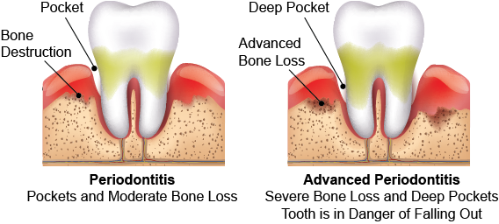
Health Canada reports in Gum Disease that there "is a strong link between gum disease and diabetes. People with diabetes are not only more at risk of gum disease, but gum disease can also affect the severity of their diabetes, putting them more at risk of diabetic complications later on in life. The same bacteria found in plaque can also be inhaled into the lungs where they may cause an infection or aggravate any existing lung condition, especially in older adults. This can happen even if you don't have serious gum disease, but have lots of plaque. Studies are also examining whether pregnant women with gum disease, including gingivitis, may be at a higher risk of delivering pre-term, low birth weight (PLBW) babies than women without gum disease."
In your learning guide, record your notes to summarize this screen.

Dietary Considerations for Preventing Dental and Oral Disease
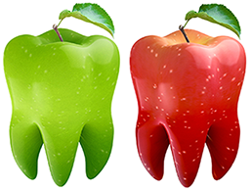
As with preventing osteoporosis, building strong teeth requires sufficient dietary calcium. Fluoride—an additive in many toothpastes and water supplies—is also important to strengthen tooth enamel. Vitamin A and C are needed for healthy gums.
What would you suggest to a mother who is giving her child raisins a few every 15 minutes or so? You have observed this at the park where the child is playing with your little sister. The mother says to you "she would eat the entire package at once if I let her."
Consider how your eating habits affect your teeth and gums and how oral hygiene affects your health. Are you at risk of periodontal disease?
In your learning guide, record your notes on the prevention of dental and oral disease.

Evaluating Sources
Throughout this module, we've been connecting dietary choices with health risks, but you might have noticed something along the way: at no point have we made a sweeping statement along the lines of "cutting out this food will prevent diabetes!" or "eat this food to beat cancer!" Reality is much more subtle: minimizing processed foods and emphasizing vegetables and fruits are two of the dietary best practices that reduce the risks of a variety of chronic conditions or diseases. Because dietary and health choices affect how you spend money, however, companies are often tempted to overpromise and oversell their products in search of greater revenues.
Because advertisers and promoters of new products or services give you only the information they choose to boost sales, you must learn to recognize reliable information and disregard misinformation for yourself. For you to be able to make informed decisions about any product or service, you must research to answer your questions. Do not believe everything you hear or read!

To evaluate the accuracy of information, ask yourself these questions:
- How does the advice being offered compare to the guidelines set out by Health Canada in Canada's Food Guide
- Are there any promises that sound too good to be true, for example, "quick fixes" or "instant cures"?
- Who is backing the information? Is the information based on testimonials, or are the claims backed with scientific research or by accredited professionals, such as dietitians, medical doctors and professional home economists?
- Are reputable sources listed for the reference materials? Claims should be backed with scientific research and studies.
- Are there any disclaimers or guarantees? Read the fine print to help ensure you are getting all of the information.
If you are unsure about the reliability of any information, ask a professional (or professional organization) such as local public health (dietitians or nurses), hospital dietitians (may need referral from your doctor) or your family doctor.
Be aware that a "nutritionist" might not be a professional at all (a "professional" is educated, certified and regulated in their practice of a profession, as is the case with teachers, lawyers, and doctors, for example). The word "nutritionist" is not registered or protected from use. Therefore, anyone may legally call themselves a nutritionist, no matter how much or how little training they have. Registered dietitians are the only professional dietitians in Canada who are legally permitted to use the designation "RD" following their name. They are a source of reliable information. Medical doctors follow their name with MD, not PhD. An academic with a PhD might have no background or training in nutrition.
Government health organizations and volunteer health organizations offer reliable health information as well:
- Health Canada.
- Dietitians of Canada.
- Heart and Stroke Foundation.
- Canadian Cancer Society.
- Diabetes Association.
- university research centers.
- WHO.
- Institute of Medicine.
- other associations related to disease or chronic conditions such as the Mayo Clinic.

Worse than uninformed resources are those that are willfully dishonest or ignorant. Less reliable information often comes from health food stores, books written to promote a product or diet, friends who have no nutrition training, or advertisements or memes from the Internet. Be aware of food fads and food quacks with pretty visual memes showing claims that not only are unsubstantiated by dietary and nutritional science but also directly refute dietary and nutritional science. Food fads are based on myths, misinformation and exaggerated claims. Food quacks use food fads to sell products and offer false hope to consumers.
Read the "Learning to Spot Fake News: Start With a Gut Check" (link found on Module 3 main page, tab 24) by Anya Kamenetz from National Public Radio (NPR) for advice on verifying and evaluating the claims you read online and in social media.
For an optional look at the disturbing trend of rejecting science and reason, watch "The Danger of Science Denial" (link found on Module 3 main page, tab 25) by Michael Specter. He describes his deep misgivings at a contemporary skepticism about science and progress. He distinguishes between demanding proof and ignoring proof. Warning: This video is sixteen minutes long, and you will not be assessed on it. View this resource only if you are very much on schedule with Nutrition with Healthy Living 120.
In your learning guide, record your notes on evaluating sources now.

Current Trends and Issues
To reiterate—to ensure that you're only acting on accurate information and good advice, you must try your best to fact check the claims you're reading, particularly on social media and from advertisers.
Still, there are a variety of current trends and issues related to nutrition and diet that are not so easily fact-checked or explored:
- fad diets.
- holistic approaches.
- sport nutrition.
- vegetarianism.
Over the next several pages, we will look a little closer at these trends and issues. We'll start with a quick look at fad diets, including the Atkins and Paleo diets.
For more on evaluating food diets, watch "How To Spot a Fad Diet" (link found on Module 3 main page, tab 26) by Mia Nacamulli. As you watch, ask yourself whether you think fad diets work. We will return to this idea later in the module.
In your learning guide, write your notes on fad diets now.

Holistic Approach
Merriam-Webster defines "holistic" as "relating to or concerned with wholes or with complete systems rather than with the analysis of, treatment of, or dissection into parts." In healthcare, holistic approaches are based on theories and practices that treat the whole body and its systems, mind, body and spirit. In a general sense, a holistic approach to medicine is preventive: holistic approaches focus on avoiding getting sick or developing chronic diseases and conditions as much as is currently possible. Traditional medicine and healthcare, however, is generally more focused on treating illness, diseases and conditions.
Does this sound familiar? The wellness wheel that we learned about in Module 1: Health and Wellness is an example of a holistic approach.
Nutrition plays an important role in any holistic approach to health. As you have seen, a person's diet can impact many diseases and chronic conditions. Many professions aimed at improving health include nutrition training in their practice, including conventional medical doctors, naturopathic doctors, dietitians and even many personal trainers. How much training in nutrition a professional has received and how much emphasis they place on nutrition in their practice will vary depending on the profession and the individual.
In your learning guide, write your notes about holistic approaches now.

Vegetarianism

Definitions

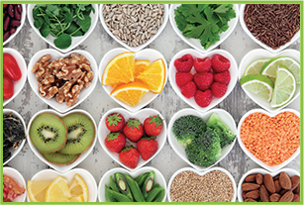
Generally, a vegetarian diet excludes meat, chicken and fish but still includes eggs and dairy products. A person who follows this type of diet is called a "vegetarian" or, more specifically, a "lacto-ovo vegetarian."
A diet that excludes all animal products is called a vegan diet.

Health Benefits
A healthy vegetarian or vegan diet is associated with lower rates of obesity, heart disease, high blood pressure, high cholesterol, Type II diabetes and certain types of cancer.

Nutrients That Might Be More Difficult To Get
All nutrient needs for people in all stages of life, including pregnant or breast-feeding women and older adults, can be met on a vegetarian diet. Supplements or fortified foods might be needed for vegans to meet all of their nutritional needs.
It may take a little extra planning to ensure the following nutrient needs are met:
- Protein:
  - Meat is high in protein, but non-meat sources include soy, dried beans, grains, nuts, dairy products and eggs.
- Iron:
  - Plant-based iron (non-heme iron) isn’t as well-absorbed as is iron from animal foods (heme iron). Therefore, vegetarians need about twice as much iron as people who get their iron from animal sources.
  - Good non-meat sources include soy, dried beans, fortified grains, some nuts, some vegetables (like spinach) and blackstrap molasses.
- Zinc:
  - Good plant sources include soy, dried beans and lentils, some nuts and seeds, whole grains and fortified cereals.
- Omega-3 fats:
  - Good plant sources include canola oil, ground flaxseed and walnuts.
In addition, vegans might have trouble getting enough of the following micronutrients:
- Vitamin B12:
  - Nutritional yeast is the only vegan food source.
  - Other sources are supplements or fortified foods.
- Vitamin D (fortified foods):
  - Exposure to sunlight can stimulate the body’s production of vitamin D, but there are no good plant-based sources of this vitamin.
  - Vegans will need supplements or fortified foods.
- Calcium:
  - Good plant-based sources include beans, some dark green vegetables, blackstrap molasses and almonds
For more on vegetarianism, watch "Why I'm a Weekday Vegetarian" (link found on Module 3 main page, tab 27) by Graham Hill. He advocates a middle ground approach to vegetarianism. He reminds us that there are environmental debates centred around vegetarianism.
In your learning guide, write your notes about vegetarianism now.

Now complete and submit –
  - Discussion Question 1 – Food Guide Comparison
  - Assignment 1 – Perfect Week

