Module 4 – Food Advertising and Technologies

In this module, you will explore not only food advertising and food labelling but also some of the procedures used in producing, storing and preparing the foods we eat.

Module Objectives:
On successfully completing this module, you will be able to:
- explain how advertising affects food choices.
- identify the role of additives and the regulations governing them.
- identify mandatory and optional information found on labels.
- identify food technologies.
- identify genetically modified foods.
- identify organic foods.
- identify natural foods.
- identify procedures used in safe food handling and preventing food-borne illnesses:
  - storage.
  - preservation.
  - sanitation.

Food Additives
According to Health Canada, a food additive is any substance that is added to a food during preparation or storage for one or more of the following reasons:
- maintaining or improving the nutritional value of the food.
- improving the storage quality of the food.
- making the food more attractive or palatable (tasty)—but not deceptively.
- aiding in food production, transport or storage.
- accommodating special dietary needs.
Additives become part of a food and affect its characteristics. Colourings, for example, can make a food more appealing while other additives can help to keep salt and other powders from clumping. Additives can extend the storage life of foods and make transporting food over long distances possible, especially for fresh foods. This allows us to have more variety in our food supply.
All items that are added to and become part of a food item are ingredients of that food. However, not every ingredient that is added to a food is considered an additive. Food ingredients such as sugar, salt, starch, seasonings, spices, and flavourings are not considered additives. Similarly, vitamins, minerals and amino acids are not food additives. It should be noted, though, that some of these nutrients can have the same function as food additives. Vitamin C, for example, is a preservative: it helps to preserve colour and freshness, and its low pH can also inhibit growth of bacteria.
In general, ingredients that are not considered additives are themselves foods or derived from foods, even if they are rarely or never consumed separately. Salt is an ingredient: the anti-caking agent that prevents salt from clumping is an additive. Health Canada specifically excludes from their definition of additive "any nutritive material that is used, recognized or commonly sold as an article or ingredient of food."

Health Canada Regulations
Health Canada outlines the regulations for food additives in the Food and Drug Regulations. The Canadian Food Inspection Agency (CFIA) enforces the health and safety aspects of these regulations, and the CIFA is also responsible for the regulations on food packaging, labelling and advertising.
According to regulation, food additives must be tested and evaluated for toxicity, and only those judged to be safe may be used.
Once additives are approved for use, Health Canada issues regulations to control how they are used:
- how much of the additive manufacturers can use.
- in which foods manufacturers can use the additive.
- why manufacturers can use the additive.
Health Canada monitors and controls the use of the additive. It conducts further testing and periodic studies, and it can withdraw an additive if Health Canada proves it to be unsafe or ineffective. Moreover, some additives approved in Canada might not be approved in the US and vice versa.
Look at the Dictionary of Food Additives (link found on Module 4 main page, tab 3) from Health Canada. This lists all of the food additives legally permitted for use in Canada. The codes (link found on Module 4 main page, tab 4) indicate why manufacturers use the additives.

Uses of Food Additives
As we've seen, Heath Canada's Health Products and Food Branch approves additives for specific purposes and uses:
- anticaking agents.
These additives prevent foods from sticking together and clumping. These agents keep table salt running freely from the box. They are used in many dry and powdered mixtures. Some commonly used anticaking agents are magnesium carbonate, calcium aluminum silicate, cellulose and propylene glycol.
- bleaching, maturing or dough conditioning agents.
These additives accelerate the aging process (oxidation) to develop gluten characteristics of flour and to improve baking qualities; they also whiten flour. They are used in flour, bread, bakery goods, cereals, instant potatoes, cake mixes and other dry mixes. Some common agents in this category are calcium stearoly-2-lactylate, potassium iodate, sodium stearoly-2-lactylate, acetone peroxide and, as you've already seen, chlorine dioxide.
These additives prevent food spoilage by delaying and preventing not only rancidity but also browning or discolouration because of oxidation. Oxidation damages the appearance, flavour and nutritional value of a food. These additives are commonly used in processed fruits, baked goods, cereals, snack foods, fats and oils, dressings, sauces, and instant potatoes. Common examples of antioxidants are vitamin C (ascorbic acid, erythorbic acid, or sodium ascorbate), vitamin E (tocopherol), Butylated Hydroxyanisole (BHA), Butylated Hydroxytoluene (BHT) and sulfites.

- colouring agents.
These additives restore or add colour to food to make it more attractive and appealing. In some cases, colours are also used to identify flavours; for example, a green sucker will probably be lime-flavoured while a black one will most likely be licorice-flavoured.
Artificial colours are only used when needed. Some natural pigments are also used to colour food; for example, caramel is used to tint foods brown, and carotenoids (pigment in plants) are used to colour margarine, cheeses and pastas yellow.
Colouring agents are known by different names in different countries. For example, the same additive is known as amaranth in Canada, Red #2 in the United States and E 123 in Europe.
- emulsifying, gelling, stabilizing or thickening agents.
These additives are used to control and stabilize the texture of a food during its shelf life:
  - Emulsifiers keep liquids, such as oil and water or oil and vinegar, from separating, as in salad dressings.
  - Stabilizers keep suspended food particles from separating and settling down to the bottom of the container. Stabilizers keep the chocolate suspended in your chocolate milk!
  - Thickening agents change the consistency of processed foods to make them thicker.
  - Gelling agents are specific types of stabilizers and thickeners that provide texture through the formation of a gel. An example here is carrageenan, which is derived from seaweed and is often added to products such as ice cream, yogurts and sauces.
- food enzymes.
These additives are used to catalyze a chemical reaction in the production of food. Lactococcus lactis is one example in this category. It is a bacterium that converts lactose to lactic acid. This conversion curdles milk, causing it to separate to form curds. These curds are then used to produce cheese and whey.
- firming agents.
These additives are used to make or keep a food firm or crisp. A firming agent, such as calcium citrate or calcium chloride, is added to many canned fruits and vegetables.

- glazing or polishing agents.
These additives are applied to the outside surface of a food to make it shiny or to provide a protective coating. Beeswax, carnauba wax and mineral oil are examples in this category, and they are often used on candies and chocolates.
- food additives with other accepted uses.
These additives have a variety of other uses. Additives in this category include the caffeine that is added to colas to characterize the product.
- sweeteners.
These additives are used in candies, gum, confections, baked goods, cereals, beverages, special dietary foods and other processed foods. Many natural sweeteners, such as corn syrup, dextrose and fructose, are simply considered ingredients, not food additives. Aspartame, sorbital and steviol glycosides are all examples of additives used as sweeteners.
One example of an additive used as a sweetener illustrates how Health Canada monitors and controls the use of additives over time as was explained on the previous screen. Saccharin is a sweetener that is used in many countries, but Canada banned it as a food additive during the 1970s because studies showed it caused cancer in rats. Health Canada revisited the subject during the early 2000s and concluded that the previous studies on rats were not applicable to humans. Saccharin underwent a re-approval process and was officially put back on the list of permitted sweeteners in 2014.
- pH adjusting agents, acid-reacting materials and water-correcting agents.
These additives are used to change or to maintain the acidity or alkalinity of food or to prevent a food from drying out. They can affect the texture or taste of the product, and the change in pH can also inhibit microbial growth. They are found in such foods as baked goods, beverages, fruits, vegetable oils, frozen desserts, sauces, dressings, relishes, pickles, and dry and condensed milk. They include acetic acid, citric acid, lactic acid, phosphates, phosphoric acid, sodium acetate and tartaric acid.

- preservatives.
These additives prevent food spoilage from bacteria, molds, fungi and yeast to extend the shelf life of food and to protect the natural colour and flavour or the food. Historically, sugar and salt were common preservatives: salt was used for centuries to preserve meats and fish, and sugar to preserve fruit in jams and jellies. Both salt and sugar withdraw water: with water unavailable to microorganisms, they cannot survive.
Currently, food processors have moved beyond using sugar and salt to preserve foods; now, they use many chemicals to control microbial growth. (In fact, Health Canada does not even consider table salt or sugar to be food additives; they are simply ingredients.) These preservatives are commonly found in fruit products, acidic foods, margarine, mayonnaise, cheeses, frozen desserts, baked goods, cured or processed meats, syrups and beverages. They include such additives as ascorbic acid, benzoic acid, sorbic acid, citric acid, calcium sorbate, sodium nitrite, sodium nitrate, and potassium sorbate.
The use of nitrites and nitrates in food is controversial. The human body converts nitrites to nitrosamines. Although nitrosamines cause cancer in animals, the levels of nitrites in food are below the levels proven to have this effect in animals. Still, the Canadian Cancer Society recognizes consuming processed meats as a risk factor for developing colorectal cancer—be it from the nutritional profile of the processed meats or the additives.
- sequestering agents.
These additives are used to control the availability of cations (positively charged ions) by combining with metallic elements, such as copper and iron, in food. This process can prevent reactions that would have otherwise degraded the colour or flavour of the food, especially in canned products.
- starch modifying agents.
These additives modify the structural properties of a starch to enable it to withstand processes such as heating and freezing. This modification helps to maintain the appearance and consistency of foods such as mixes, sauces and custards.

- yeast foods.
These additives are used as nutrients to grow yeast, which is used in making breads and some beverages, such as beer.
- carrier or extraction solvents.
These additives physically modify another additive, ingredient or component of a food without impacting the food itself on their own. They can be used, for example, to dilute and distribute flavours throughout a food or to extract fats and oils from seeds.

Unintentional Additions to Food

Whereas food additives are intentionally added to food during processing or preparing for storing, other substances can be added to foods accidentally or indirectly. Unintentionally introducing components to food can happen during the growing, processing, packaging, storing or cooking of a food when it comes in contact with a substance not normally put into the food. The substances added accidentally are not considered additives under Health Canada regulations, but they are sometimes refered to as "indirect additives."
These unintentional additions to food can include such things as the hormones or antibiotics administered to animals before slaughter; the pesticides sprayed on plants before harvest; packaging materials; or tiny bits of paper, glass, metal, and so on that can accidentally get into food during processing. Often, the discovery of these substances in foods makes headline news, and consumers are generally well-aware of any concerns created.
In your learning guide, complete your notes about food additives now.
Understanding the information on food labels will help you to compare food products more easily, to determine the nutritional value of foods, to better manage special diets, and to increase or decrease your intake of a particular nutrient.
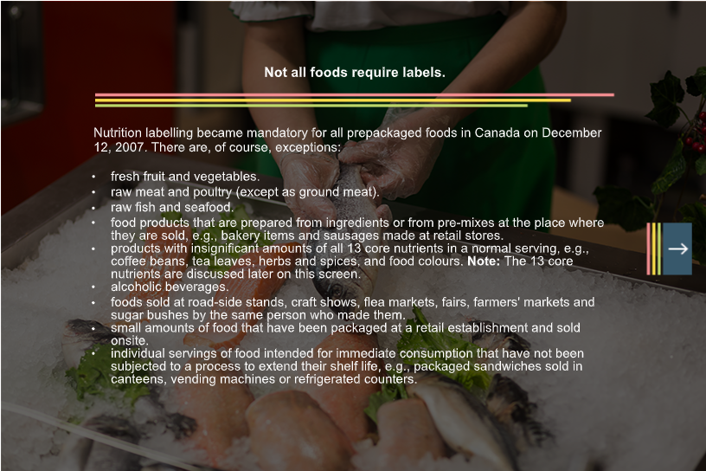
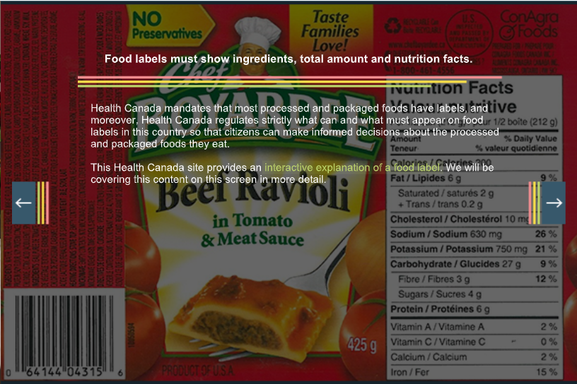
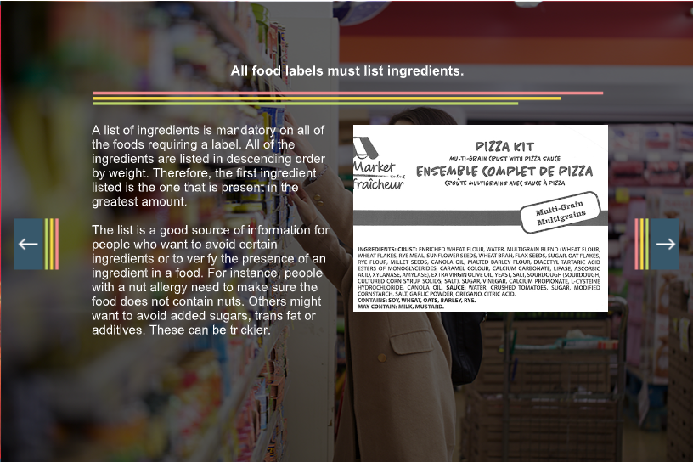
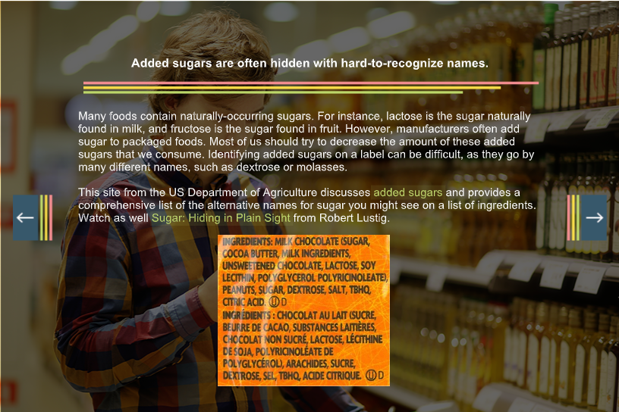
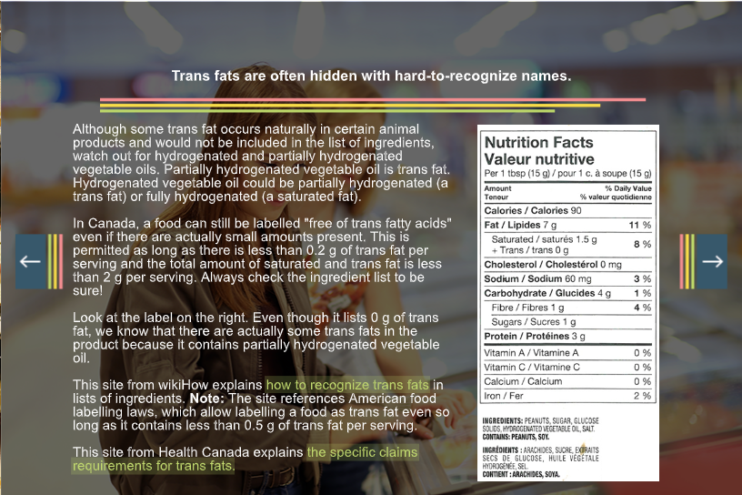
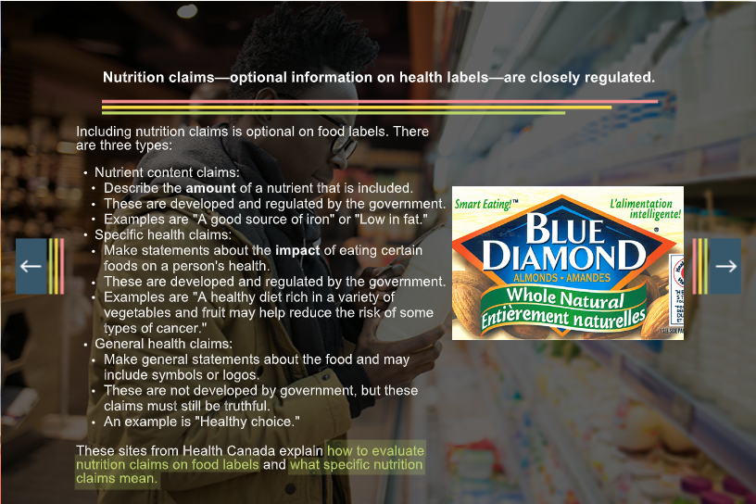
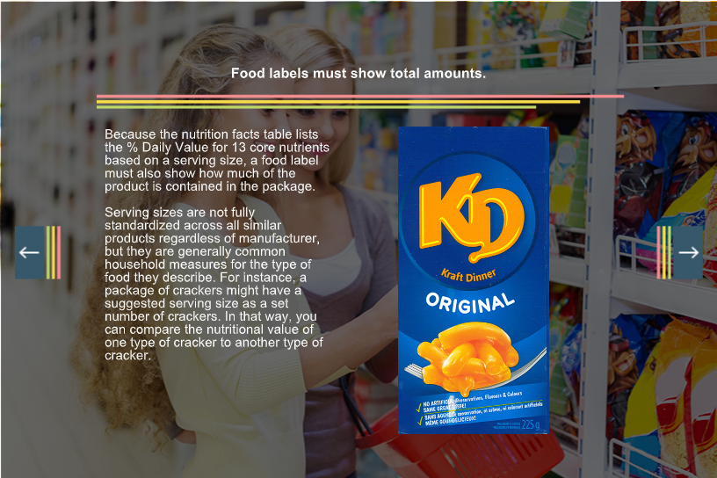
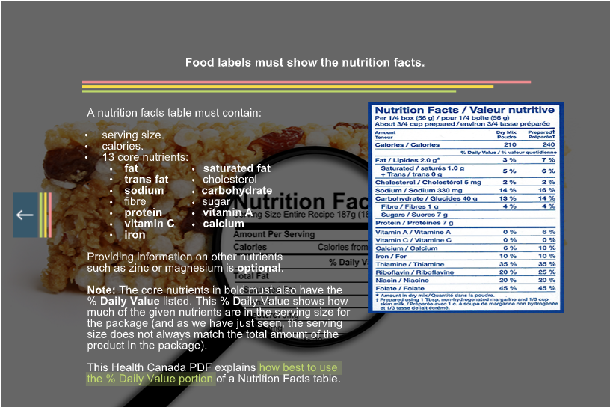
This Health Canada presentation provides an in-depth look at food labelling (link found on Module 4 main page, tab 5). It is meant for educators and healthcare providers. Make sure you read the speaker's notes in the Notes pane, too!
Go to your learning guide to focus your research on food labelling now.

Food Technologies
Now, we will consider the impacts of a few different ways in which food is raised or grown:
- Genetically Modified (GM) foods.
- organic foods.
- natural foods.
- local foods.

GM Foods
The first food technology that we will discuss is Genetically Modified (GM) foods—a controversial topic. GM foods can be produced and sold in Canada.
What are GM foods? The World Health Organization defines them as:
Organisms in which genetic material (DNA) has been altered in a way that does not occur naturally by mating and/or natural recombination….It allows selected individual genes to be transferred from one organism into another, also by non-related species.
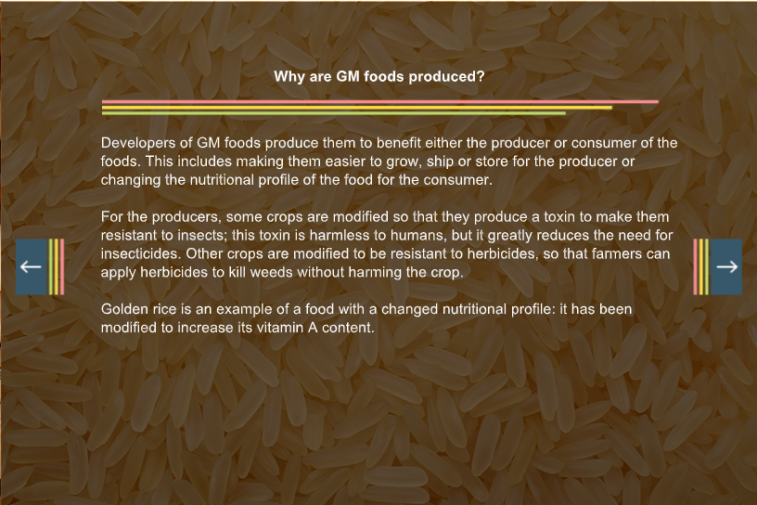
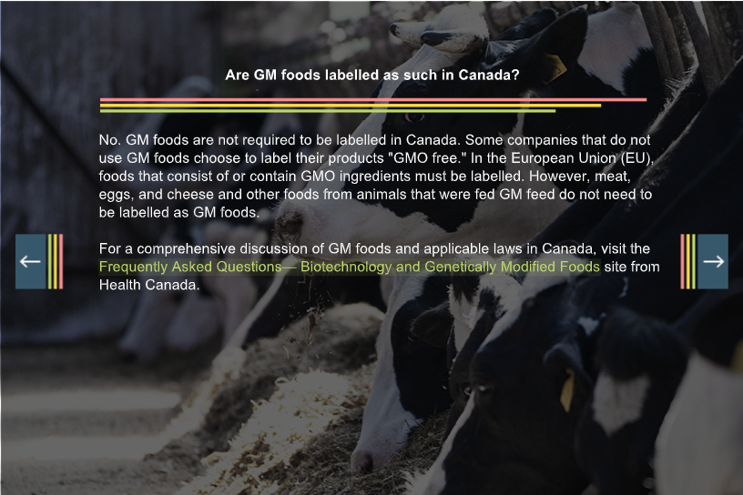
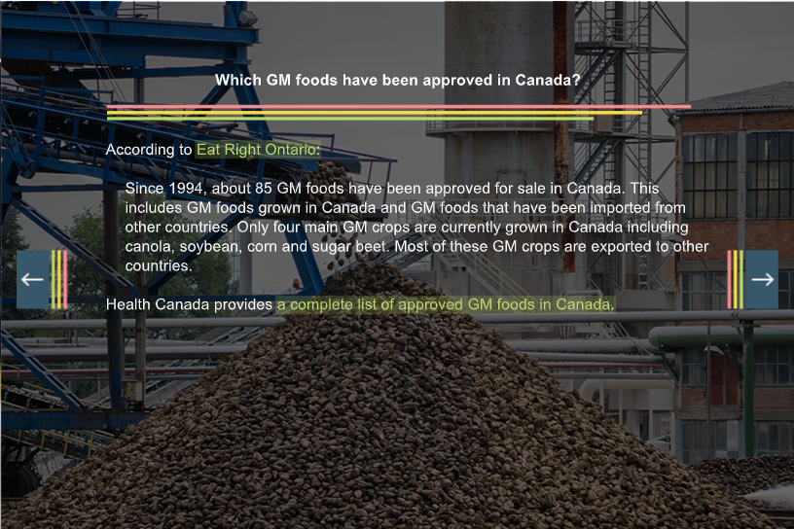
There are three principle concerns with GM foods: allergic reactions, gene transfers, and environmental concerns.
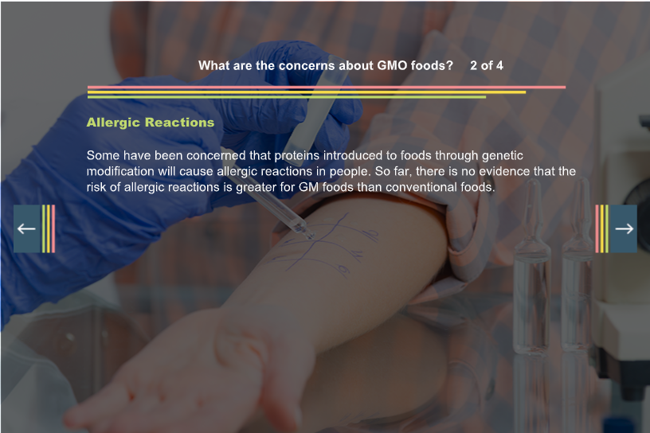
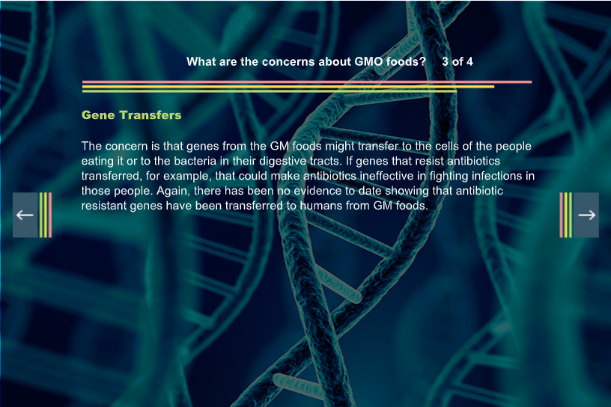
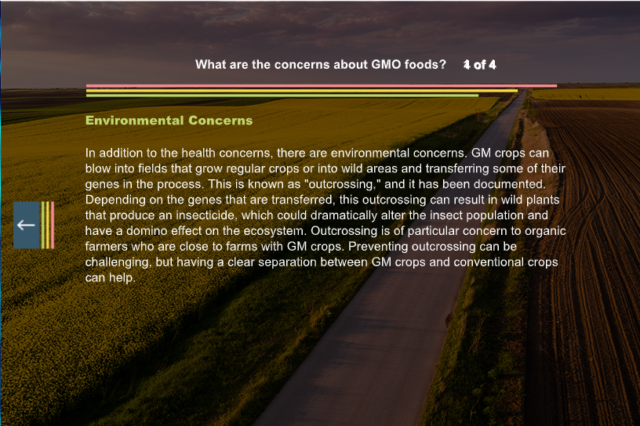
Check out the WHO's the discussion of GM foods (link found on Module 4 main page, tab 6) on which this page was based.
In your learning guide, write your notes about GM foods now.

Organic Foods
Organic foods are those produced or raised without synthetic or manufactured chemicals as fertilizers and without pesticides. Proponents believe that keeping synthetic or manufactured chemicals out of the human food supply will benefit human health and that organic methods of production are better for the environment than are conventional methods.
The Government of New Brunswick (partially itself quoting the federal government) defines organic food production as the following:
Organic production is a system whose ultimate goal is the preservation of the environment and the production of healthy and safe foods. Practitioners follow specific growing, handling and processing standards from the soil to the consumer's table.

The key objectives of this production system are the preservation of soil life, the sustenance of soil humus, the protection of ground water, the elimination of synthetic or "chemical" fertilizers and synthetic pesticides from the food supply, and the maintenance of the health and economic welfare of farmers. Not only does this system prohibit the use of highly soluble fertilizers and synthetic pesticides but it also prohibits the use of synthetic growth regulators, irradiation as a food preservation technique, genetically modified organisms (GMO) and intentionally manufactured nano-technology products. There are also very strict protocols on the use of manure, compost and antibiotics.
Labelling regulations for organic foods vary across the country; in NB, any product labelled "organic" must be grown and processed according to the organic standards of the certification organizations. These organizations have independent inspectors to verify the integrity of the organic production system.
Federal regulations mandate compliance with organic standards for products labelled as such that are sold from province to province (or territories), products that are imported, or products that use the federal organic logo. For products not sold between provinces or territories or not displaying a federal organic logo, the Health Canada regulations are not very strict, however.
In your learning guide, summarize this content on organic foods now.

Natural Foods
In contrast to GM foods or even organic foods, natural foods are foods grown and marketed without the use of much obvious food technology. Because food manufacturers market and label their products with the label "natural" or other similar slogans or phrases, the Canadian Food Inspection Agency has specific rules for the labelling a method of production as "natural":
- Only foods without added vitamins, minerals, flavouring or additives can be called natural.
- Only those foods that have not been significantly changed physically, chemically or biologically can be called natural.
- Only foods that have not had parts or elements removed (with the exception of water) can be called natural.
Unprocessed or natural foods have become increasingly promoted as healthier choices as we'd seen with Brazil's approach to a national food guide during Module 1: Wellness. Still, the Canadian Food Inspection Agency specifically warns against misleading consumers by overpromising benefits from natural foods:
Labels and advertisements should not convey the impression that "Nature" has, by some miraculous process, made some foods nutritionally superior to others or has engineered some foods specially to take care of human needs. Some consumers may consider foods described as "natural" as being worth more than foods not so described.
In your learning guide, summarize this content on natural foods now.

Local Foods

Local foods—while not specifically the result of using or rejecting a specific technology or practice—have also become recently trendy. While there is no universally accepted definition of "local," books such as The 100-Mile Diet: A Year of Local Eating have led many to use the term in reference to foods produced within 100 miles (160 km) of where they are consumed. Others would push those boundaries a little further to include anything grown within the province or general region. No matter where the limits are set, the people who promote the consumption of locally produced foods see the following advantages:
- Reducing the carbon footprint of consuming foods because of lower shipping distances.
- Boosting local economies, including diversifying businesses.
- Increasing focus on fresh fruit and vegetables.
- Increasing food security.
- Revitalizing rural communities.
- Increasing knowledge of food production.
- Focusing on more sustainable methods.
NB households spend $2.6 billion on food each year, most of which is produced elsewhere. In 2014, in NB, the agriculture and agri-food sector comprised 2,600 farms and 140 processing plants, which combined, generated 17,700 jobs, most in processing plants (10,600). In 2014, NB's farms and fisheries combined to generate nearly $1 billion in revenue with the processing plants for each sector each also generating more than $1 billion in revenue.
The self-sufficiency of a food item is defined as producing enough to meet 100% of the needs of the population. A self-sufficiency rating of less than 100% means that a region must import these items while a rating of more than 100% means that a region can export these excess items.

New Brunswick's self-sufficiency ratings for different types of food items:
Low-Self Sufficiency
Vegetables (8%), grain (57%— mostly used for livestock feed), beef (21%), and pork (20%)
Self-Sufficiency
Milk, eggs, chicken and turkey: 100% (This is due to the supply-management systems that are in place, such as the quota system for milk.)
High Self-Sufficiency
Potatoes, wild blueberries, maple syrup and seafood: over 1000%
In your learning guide, summarize now what you have learned about the dimensions of wellness.

Food Safety
Now we will shift our attention to another important way in which our food choices can affect our health and wellness: food safety. Food safety is how we should handle, store, preserve and prepare food to avoid food-borne illnesses—getting sick from the food we eat.

Food Deterioration
Food deteriorates as a result of one of the following conditions:
- enzyme action in the living cells.
Enzymes are chemical substances produced in the living tissues of all plants and animals. They speed up the changes that eventually occur in plant and animal tissue cells. In vegetables, enzymes are responsible for the normal ripening or maturing of the plant. In meat, enzymes break down muscle tissue, and this process makes meat tender. Enzyme action continues after the fruit or vegetables are picked or the animal is killed. Enzymes can be inactivated by heat or inhibited by cold temperatures.
- microorganisms such as moulds, yeasts or bacteria.
Microorganisms include many varieties and strains of moulds, yeast, parasites, viruses and bacteria. Some are harmless, some are hazardous, and some are useful in food production and medicines. We will discuss these in greater depth in our discussion on food-borne illnesses. Most microorganisms must have the right conditions for a long enough period of time to multiply enough to impact the quality and safety of food. They must have warmth, moisture, and the proper pH balance; most also need oxygen. When left in optimum conditions for more than two hours, their numbers will increase to dangerous levels, and this growth contaminates the food and can cause illness in anyone who consumes it.
- oxidation.
Oxidation refers to exposing a food to oxygen in the air. In fruit and vegetables, this occurs in combination with enzyme action. Together, they cause a brown discolouration of the surface and often a softening of the food. Exposure to the air also causes dehydration and a loss of vitamins, especially water-soluble vitamins.
In your learning guide, complete the section on food deterioration now.

Food Storage
The goal of food storage is to protect the food against one or more of the three causes of food deterioration. Storing food properly helps to prevent spoilage and waste and, therefore, saves money. It also preserves the flavor, texture and nutrients of the food and protects the food from contaminants, such as dust, dirt, insects and other pests.
There are three main types of storage used both commercially and at home:
- Refrigerated
Refrigerated storage is used for foods that spoil easily and will be kept for a short period of time; perishable foods are kept in the refrigerator. These foods include meat, fish, poultry, milk, eggs, dairy products and prepared foods that are left over from meals. Most fruit and vegetables are also refrigerated to keep them fresher longer. Some, such as potatoes, sweet potatoes, squash, onions, turnip, eggplants and citrus fruits, can be kept in cool temperatures slightly below room temperature for a limited time. Check food labels for storage instructions as well. Some foods previously kept in dry storage will need to be refrigerated after the container is opened.
Your refrigerator temperature should be kept at 3–4°C. Within these temperatures, microbial growth slows, and therefore, food spoils slowly. The bottom section of the refrigerator is normally colder than the top section or the door; therefore, highly perishable foods should be kept near the bottom section. Foods should also be wrapped to prevent drying and to keep other foods from cross-contaminating one another. Foods with strong flavors and odours should be separated from those that absorb flavours and odours. For example, cover and store diced onions or fish away from milk or cheese.
Food can be kept in the refrigerator from a day to a few weeks, depending on the type of food. Check labels and package dates to see how long the food is of peak quality. These dates apply provided the package was not opened. As soon as the package is opened and the vacuum seals are broken, the food might not keep as long. Food that is going to be kept for longer storage should be preserved. The quickest and easiest method is freezing.
- Frozen
Frozen storage is used for foods that you want to keep for weeks or months before using. These foods are often sale items or seasonal foods that you don't want to use immediately. Your freezer temperature should be kept at -18°C or below for long-term storage.
Not all foods freeze well, and some freeze better at other temperatures. Meat, poultry, fish, bread, baked goods, and casseroles freeze well. Egg whites, gelatin, foods with mayonnaise, and some raw vegetables do not freeze well. Most vegetables should be blanched—submerged into first boiling and then very cold water—before freezing. This protects their flavor and texture and shortens their cooking time when you are ready to use them.
Foods bought already frozen normally can remain in their original package and be placed in your freezer. You must protect other foods you want to freeze with freezer paper, plastic freezer bags, heavy aluminum foil or air-tight containers. Foods that are not properly wrapped will lose moisture in the freezer and become freezer burned. Dry or freezer-burned food is still safe to eat, but the flavor and quality of the food is affected. Dating foods as you freeze them can be helpful in determining when the food was frozen and what should be used first.
Frozen food can sometimes be refrozen safely. Here are some guidelines to follow:
  - Discard thawed or perishable food held at room temperature for an unknown period of time.
  - Some labels have "do not refreeze" written on the label. Follow this advice.
  - Do not refreeze raw meats that have completely thawed. You may freeze it again if you cook it first or if it is not completely thawed. Do not thaw perishable food at room temperature; thaw in cold running water, the refrigerator or a microwave.
  - Although breads and baked goods are safe to refreeze, most deteriorate in texture, flavor and colour when they are refrozen. Use your own judgment in this case.
- Dry
Dry storage areas are normally cupboards and shelves that are cool, dry, well-ventilated dark and clean. Temperatures in these areas should be below 20°C. Cooler temperatures of 10–15°C—although not practical in most homes—are more desirable. Do not use cupboards over the range, refrigerator or heaters for food storage; these areas are usually warmer than other areas. Foods that are not perishable or frozen can be kept in dry storage at least until they are opened. As mentioned before, some canned or bottled foods need to be refrigerated once their seal is broken. You can dry store canned goods, cereal, crackers, most baking goods, vegetable oils, peanut butter, spices, coffee, tea and so on. After these foods have been opened, you may need to place them in air tight containers to store the remainder. This will protect the food from insects, pests and humidity.
When storing new food items, always place the new behind the old so that the older supplies get used first. Most canned goods do not have dates on the containers or packages, and you will have no idea how old the items are. Canned foods lose their flavor and texture over time. Most cereals and crackers have dates on the labels.
In your learning guide, complete the section on food storage now.

Food Preservation
The food production industry has used advances in technology not only to help to preserve food for longer periods of time but also to help increase the availability of foods from season to season the world over. The variety of preservation techniques used has equalized the supply of affordable food in all parts of this country year-round.
Food preservation methods are used to stop or slow the deterioration of food. Often two or more methods are used together. Most methods work either by killing potentially harmful microorganisms or by creating unfavourable conditions for their growth. The following are the most common food preservation methods used at home and commercially:
- canning.
Canning is the process of heating and sealing food in containers (cans or glass jars) for storage. The high temperatures used in canning stop the activity of enzymes and kill the bacteria responsible for food spoilage. A variety of foods are canned at home with fruits and vegetables being the most common. To be successful, you must have the proper equipment, choose the best method for processing and follow correct processing procedures.
Foods not properly sealed can allow the formation of botulism, a deadly form of food-borne illness. The bacteria that cause botulism do not need oxygen, so if they survive the canning process, they can thrive inside the can and spoil the food. As they reproduce, they give off carbon dioxide gas, which causes the can to swell; therefore, never eat food from bulging cans.
- pickling.
Pickling is a form of canning that uses acid (in the form of vinegar) and salt to help control bacterial growth. Canning procedures are used to seal the jars.
- dehydrating.
Dehydrating food removes the moisture that most microorganisms need. It decreases the size of the food, increases storage life, and provides the convenience of using dry storage instead of refrigerated or frozen. Some foods contain more moisture than others when dried, but generally, dried food should contain 15–20% of its original moisture.
As with other methods of preservation, proper procedures are important to guarantee the safety of the food. You must monitor air temperature and circulation to avoid bacterial growth and food spoilage. If temperatures are too hot and foods dry too quickly on the outside, moisture may be trapped on the inside, and this condition is ideal for bacterial growth. Proper air circulation and good ventilation aid in the drying process and do not allow bacteria time to reproduce. Once the moisture content is below 16%, bacteria do not normally survive. Dehydrators are a safe and efficient method of drying foods.
Sun drying is a popular method of drying foods. You probably have noticed it on the labels of some dried foods, for example "sun-dried" tomatoes. Many fruits are also sun-dried. Sun drying requires a very warm sunny day with low humidity.

- freezing.
Freezing is a very easy and convenient way to preserve food. It does not destroy bacteria or enzymes, but both become inactive, and bacteria cannot reproduce. The extreme cold inhibits their growth and activity.
Other commercial methods of food preservation are:
- freeze-drying.
Freeze drying combines the theories of drying and freezing to control enzyme and bacterial growth and activity. This is an expensive commercial process carried out only on high quality food. First, the food is flash frozen in a low-pressure chamber. Then, while in the frozen state, up to 99% of the foods moisture is removed using low temperature condenser plates that withdraw vapour from ice crystals. Bits and pieces of foods in instant soups and baking mixes, instant coffee, milk powder, and instant potatoes are examples of freeze-dried foods. These foods can be stored for years.
- aseptic packaging.
Like canning, aseptic packaging involves sterilizing foods by heating and then placing them in sterilized containers. Sterilization can only take a few seconds, and this retains the nutrient content and flavor of the food. After the food is sterile, it is quickly cooled to retain its quality, and then, it is packaged. This method of processing and packaging food has meant that products can be stored at room temperature for long periods of time. It can even be used for such perishable foods as milk, cream and orange juice.
- irradiation.
Irradiation involves exposing food to a controlled amount of radiation for a specific time to destroy the microorganisms that could cause the food to deteriorate. Radiation involves one of three types of ionized energy:
  - gamma rays.
  - machine-generated electrons.
  - X-rays.
Bacteria, yeasts, and moulds are broken down, and parasites and insects (or their eggs or larvae) are either killed or made sterile. Destroying these pathogens and organisms not only reduces the risk of food-borne illness and insect infestation but also extends the shelf life for treated foods. In Canada, all food treated with irradiation must be labeled so and display the logo "Radura". Any advertising for the food products must reveal that the food is irradiated.
Irradiation is controlled by Health Canada under the Food and Drug Regulations, Part B, Division 26. Foods permitted to be irradiated in Canada are potatoes, onions, spices, dehydrated seasonings, wheat, flour, whole wheat flour, fresh and frozen ground beef, fresh and frozen poultry, pre-packaged shrimp and prawns, and mangos.
- use of additives.
As you have already seen, several different ingredients can be added to foods to help to preserve them. These include wood smoke, spices, sugar, salt and vinegar.
Do you remember any of the food additives allowed in Canada to be added by manufacturers to prevent food spoilage? Earlier in this module, we discussed two types of intentional food additives that prevent food spoilage:
  - antimicrobial agents (preservatives) such as sodium nitrate and sodium nitrite.
  - antioxidants such as vitamin C and vitamin E.
Watch "Are Food Preservatives Bad for You?" (link found on Module 4 main page, tab 7) by Eleanor Nelson a brief overview food preservation practices and their health implications. (This video lists two types of deterioration: it includes enzyme actions with oxidation whereas we have split those causes in this course.)
In your learning guide, complete the section on food preservation now.

Food-Borne Illnesses

Have you ever heard someone say "It must be something I ate" after experiencing stomach cramps, diarrhea or vomiting? Have you ever experienced these symptoms yourself and just assumed that you had the flu? The symptoms for the flu and some food-borne illnesses are very similar; this makes diagnosing food-borne illnesses difficult. A food-borne illness, commonly called "food poisoning," is an illness caused by consuming contaminated food or water. There are many sources of food contamination and several types of food-borne illnesses. Health Canada believes there are far more cases than what are diagnosed or reported because of the variety of symptoms and similarities and confusion with other illnesses.
Symptoms can appear within 30 minutes of eating the contaminated food or as late as 2 weeks following consumption. Most symptoms appear within four to forty-eight hours. You should see a doctor if you experience bloody diarrhea, frequent diarrhea and vomiting, stiff neck and severe headache, dizziness or blurred vision, high or persistent fever, or any other symptom of a food-borne illness that lasts longer than two days. Some food-borne illnesses can be fatal if not treated immediately, especially in children, pregnant women, the elderly, and those with weakened immune systems. The important thing to remember is that food-borne illnesses are preventable with proper food handling.

Causes of Food-Borne Illnesses
Common causes of food-borne illnesses are the following:
- bacteria.
The most common cause of food-borne illness is bacteria; these microorganisms are everywhere. Many foods contain bacteria when you purchase them. Bacteria are also on our bodies, in the air, on work surfaces, and so forth. Proper sanitation techniques are essential when handling food. If food is not handled and stored properly during its production, transportation, sale, pre-preparation and cooking, it can become contaminated and become unfit for consumption. You cannot see, taste or smell these microorganisms. Cold inhibits their growth, and most are killed by proper cooking methods.
Bacteria act in one of two ways: causing infections themselves (food-borne infection) or producing the toxins that cause illnesses (food-borne intoxication). With a food-borne infection, food is contaminated with pathogenic bacteria, parasites or viruses. The food is ingested, and then the organisms reproduce in the intestines, infect the body, and cause you to become ill. Examples of this type of food-borne illness are Salmonella, E-coli, and hepatitis A (a virus).
With food-borne intoxications, food is contaminated with pathogenic bacteria that reproduce and produce toxins. The toxic food is then ingested, and this causes illness. The toxin—and not the bacteria—makes you sick in these cases. Examples of bacteria that cause food intoxications include Staphylococcus aureus, Clostridium prefringens and Clostridium botulinum, the last of which causes botulism.
- parasites.
Parasites are organisms that grow and feed on other organisms. Trichinosis, although uncommon today, is caused by eating undercooked meat, often pork, infected with cycts of Trichinella roundworm. Once you consume these cysts, the parasite develops in the intestine and causes illness. Early symptoms include diarrhea, fever, fatigue and muscle pain. Severe infections can cause fatal damage to the heart and brain. Currently, the most common source of this illness is wild game, especially bear meat.
- viruses.
Viruses, such as hepatitis A, can also cause food-borne illness. Viruses are even smaller than bacteria and must be viewed under an electronic microscope. They are excreted in feces of infected people, and they can be passed on to food through unsanitary handling by the infected person. The infected person might even be unaware that they are carrying the virus. The virus does not grow or reproduce in food, but the infected food, if eaten, will cause harm to the individual. Once inside the body, the virus affects body cells. Symptoms can vary depending on the virus, but they can include fever, vomiting, nausea, abdominal cramps and, for hepatitis A, several days of jaundice. If possible, do not handle food if you do not feel well.
- chemicals.
Chemicals can also cause food-borne intoxications. Sometimes, toxic chemicals such as pesticides or pollutants affect food. Food must be cleaned well or not eaten at all in some cases. Natural toxins occur in foods such as poisonous berries and mushrooms. Do not eat these foods if you are unsure of what is safe and what is not.
Other sources of food contamination are caused by molds, diseases carried by rodents and flies, and water contamination. These contaminants cause food to be unfit for consumption.
For a good overview of food-borne illnesses, watch "Food Illness: What Problem?" (link found on Module 4 main page, tab 8) by the Florida Integrated Food Safety Center of Excellence. This video is American, but the statistics and trends are similar here in Canada, and the general information it provides is solid. One notable difference is that the agency in Canada responsible for the safety of our food, including food recalls, is the CFIA.

Conditions for Bacterial Growth
Generally, a few bacteria are not enough to cause illness, but they can multiply rapidly to dangerous levels. Pathogenic microorganisms need proper conditions to reproduce or produce toxins. Like all living things, they need food and moisture. They can multiply rapidly in moist, warm, protein-rich foods, such as meat, poultry, fish and shellfish, eggs, and many canned foods. Within temperatures of 4–60°C, known as the danger zone, microorganisms can multiply rapidly. Food absolutely cannot be left sitting in this temperature range for more than two hours. At room temperature (18°C), bacteria can double every 20–30 minutes. At temperatures of 35–45°C, this time is reduced by half. Health Canada warns, "Keep hot foods hot, and cold food cold." Any food left within the danger zone for more than two hours should be discarded. Below 4°C, the growth of most microorganisms is inhibited. Above 60°C, most microorganisms are killed or growth is inhibited in those that are heat stable.
Most moist foods are susceptible to microbial growth unless they contain high concentrations of salt or sugar. Salt and sugar tie up the moisture in such foods as syrups, jams, jellies, and foods in brines; this makes the moisture unavailable to bacteria. Therefore, they can be safely stored at room temperature.
Acidic conditions normally inhibit microbial growth as well. An example of this is the vinegar used in pickling. Vinegar lowers the pH and inhibits the growth of bacteria, and these effects allow you to store your pickles at room temperature.
Vacuum sealing containers will inhibit the growth of most bacteria, but there are some strains of bacteria, such as botulism, that can survive without oxygen. Keeping food in airtight containers will protect its flavor and moisture, and keep it away from insects and pests.
In your learning guide, note the causes of food-borne illnesses.

Preventing Food-Borne Illnesses
Follow these tips to help prevent food-borne illnesses:
- Shop in clean stores and buy fresh quality foods. Check labels for dates. Most labels have the “best before dates” or “packaged on dates.” These are good indicators of freshness. When you are shopping, pick up refrigerated and frozen food last, and store them first when you get home.
- Wash fresh produce thoroughly before eating. Several people may have handled this food, and it could also have chemical residue on its surface.
- Keep your refrigerator at 4 degrees Celsius or less, and your freezer at -18 degrees Celsius or less. The danger zone is between 4 degrees Celsius and 60 degrees Celsius at which bacteria can multiply rapidly.
- Thaw frozen foods in your refrigerator if time permits; and if time does not, thawing in cold running water or the microwave is safe. Cook food thawed in the microwave immediately. When thawing food at room temperature, the outside thaws first and warms to temperatures within the danger zone at which bacteria can reproduce. This practice is unsafe.
- Keep cold foods cold and hot foods hot. Control the temperature of food when waiting for it to be served or stored.
- Do not eat foods left in the danger zone temperatures for more than two hours. Bacteria can take only fifteen minutes to multiply to dangerous numbers in very warm environments.
- Practice good personal hygiene. Washing hands frequently is extremely important to protect yourself and foods from cross-contamination.
- Never use the same knife, cutting board, or other equipment to prepare two separate foods unless they are thoroughly washed between uses. Food can become cross contaminated by a knife or cutting board used to prepare food containing bacteria. If the chicken contained salmonella bacteria, so would the raw vegetables. The salmonella would be killed in the chicken when it is cooked, but if you the vegetables were eaten raw, they would be very dangerous.
- Separate and cover foods when storing to slow deterioration and avoid cross-contamination.
- Cook food thoroughly, especially ground beef, poultry, and pork. Most microorganisms are killed by heat. Use meat thermometers to check the internal temperatures of meats. Cooking times and temperatures vary from on product to another.
- Store leftovers as soon as possible. Very hot food may be left to cool for 30 minutes before putting it in your refrigerator. Stirring soups, casseroles, and so on during this time will help them to cool evenly. Dividing large amounts of food into smaller containers or sitting a large pot in cold water will help it cool more quickly. Reheat and eat leftovers within four days or discard them. For longer storage, they must be frozen.
- Store stuffing from meat and poultry separate from the meat. This practice allows the interior to cool more quickly.
- If you practice home preserving, be sure to use proper equipment and canning techniques. Discard any food that does not seal properly.
- Do not eat food from leaking or bulging cans. They can be deadly.
- Never taste a food you suspect of being spoiled. Again, if in doubt, throw it out.
For a good overview of preventing food-borne illnesses, watch "Preventing Foodborne Illness: Talking to Patients About Food Safety" (link found on Module 4 main page, tab 9) by the US Food and Drug Administration. This video is again American, but most of the information applies equally well here. Note: Food recalls in Canada are handled by the CFIA, and for your notes, you should convert temperatures to degrees Celsius.
In your learning guide, note how food-borne illnesses are prevented.

Food Advertising

Goals and Effectiveness
The goal of food advertising, as with any advertising, is to increase consumption of the item being advertised. Many of these ads are obvious, such as billboards on the side of the highway or commercials that play before a YouTube video. Others, though, are more subtle, including placing a certain cola brand in a movie scene or having a food company logo appear on a sports team’s jerseys.
We know that companies around the world spend billions of dollars every year on food advertising, but does food advertising work?
In a study published in the Journal of Healthy Psychology in 2009, elementary-school-aged children watched a cartoon that contained either food advertising or non-food advertising. All of the children were offered a snack while watching. What was the result? The children exposed to the food ads consumed 45% more food!
The same study included a similar experiment with adults, who were divided into 3 groups:
- Group 1 watched a TV program with food ads that promoted snacking or fun product benefits.
- Group 2 watched a TV program with food ads that promoted the nutrition benefits.
- Group 3 watched a TV program with no food ads.
All of the adults were then given the opportunity to taste and evaluate a range of healthy and unhealthy snack foods.
The result? Adults that were exposed to ads that promoted snacking consumed more of both the healthy and unhealthy snacks.

Current Regulations on Food Advertising
The Canadian Food Inspection Agency (CFIA) defines food advertisements as any representation that directly or indirectly promotes the sale of foods through broadcast (e.g., television or radio), the Internet or print. Advertisers must comply with the Food and Drugs Act (FDA) and the Consumer Packaging and Labelling Act (CPLA). The goal of the regulations is to enable consumers to make informed food choices based on information that is truthful and not misleading.
CFIA is responsible for enforcement and may require companies to provide evidence to show that their food labels or advertisements are accurate. In addition to these requirements for clear and truthful advertisements, food advertisers are not allowed to advertise any food to the general public as a treatment, preventative or cure for any disease or disorder. Similarly, formulated liquid diets cannot be advertised to the general public because an individual should have the benefit of medical advice before considering using a liquid diet. As well, fortified gluten-free food cannot be advertised to the general public, but non-fortified gluten-free foods can.
All of these are Canadian regulations. However, advertising from other places, such as websites that are not based in Canada, are not bound by these rules.
For a great example of the power of advertising, watch this portion of "Life Lessons from an Ad Man" (link found on Module 4 main page, tab 10) by Rory Sutherland, a British advertising executive.
In your learning guide, prepare your notes on food advertising now.
Now complete and submit –
  - Discussion Question 1 – Food Guide Comparison
  - Assignment 1 – Perfect Week

